GRADUATION PROJECT REPORT
TrendScope
YouTube Trend Discovery & Business Intelligence Platform

Submitted by:
Aesha Alami — Student ID: 202330074
Supervised by: Dr. Husam Barham
Course: 307498 — Graduation Project
Second Semester, 2026
Submission Date: June 2026

Abstract
TrendScope is a Business Intelligence platform designed to transform YouTube into a real-time trend observatory. By entering a single keyword such as AI, Electric Vehicles, or Real Estate, business analysts, marketers, content strategists, and researchers gain immediate access to a structured intelligence layer that reveals what topics are rising, which channels dominate a space, how audience sentiment shifts over time, and what related keywords are emerging around any theme.
The platform was built using a complete end-to-end data pipeline. YouTube video metadata is collected through the official YouTube Data API v3, covering search results, video statistics, channel information, category labels, and comment samples. The raw data is transformed through a multi-stage Python processing pipeline that normalises fields, extracts temporal features, computes engagement scores, runs transformer-based sentiment classification on comment samples, and applies topic modelling to identify dominant themes across result sets. All processed datasets are structured into a relational schema and persisted as analysis-ready CSV files and a SQLite database.
Results are surfaced through two complementary interfaces: a Streamlit web application for interactive, keyword-driven exploration, and a Microsoft Power BI dashboard for executive-level analytics and historical trend comparison. Key findings include the ability to detect trend velocity and saturation, identify early-rising channels before they peak, surface dominant audience concerns through comment sentiment, and map the semantic neighbourhood of any keyword through related topic clustering.
TrendScope demonstrates that publicly available YouTube data, when systematically collected and intelligently processed, constitutes a powerful and underutilised business intelligence asset applicable across industries including media, marketing, investment research, and competitive intelligence.

Acknowledgment
I would like to express sincere gratitude to Dr. Husam Barham for his clear and precise project direction, which challenged me to think beyond narrow technical implementation and focus on building genuine business intelligence value. His guidance in reframing the project around keyword-driven trend discovery transformed the direction of this work and sharpened its practical relevance.
I also acknowledge the open-source community whose tools made this project technically feasible: the YouTube Data API v3 team at Google for providing structured programmatic access to YouTube's data; the Hugging Face team for the transformer-based sentiment models used in comment analysis; the Streamlit team for enabling rapid, polished web application development without frontend engineering overhead; and the Microsoft Power BI team for providing a world-class business intelligence visualisation environment.
Finally, I extend appreciation to my peers and family for their encouragement and patience throughout the intensive development and documentation process that this graduation project demanded.

Business Intelligence Project Description and Objectives

Industry Context and Problem Domain
YouTube is the world's second-largest search engine and the dominant platform for video content consumption, with over 800 million videos and more than 500 hours of new content uploaded every minute. This makes YouTube one of the richest, most dynamic, and most underutilised business intelligence data sources available to analysts, marketers, and strategists.
Every search performed on YouTube, every video that gains traction, every spike in engagement, and every comment thread reflects real consumer interest in real time. When electric vehicle searches surge on YouTube three months before a competitor announces a new model launch, that signal has commercial value. When a niche cooking technique channel grows from 10,000 to 500,000 subscribers in six weeks, that is a trend intelligence asset for the food industry. When audience comments on technology videos shift from curiosity to scepticism over a twelve-month period, that sentiment evolution matters to investors and product teams.
The challenge is that this data is unstructured, voluminous, multilingual, and scattered across millions of individual videos and channels. No business analyst can monitor it manually. There is currently no accessible, general-purpose BI tool that allows a non-technical user to enter a keyword and receive a structured, visual, interactive intelligence briefing about that topic's presence, evolution, and audience reception on YouTube.
TrendScope fills this gap.

Why YouTube?
YouTube was selected as the data source for four strategic reasons. First, it operates as a search engine, meaning query-matched data collection is native and structured. Second, it provides rich metadata per video including view counts, like counts, comment counts, subscriber counts, publish dates, category labels, and duration, all of which are analytically meaningful. Third, the YouTube Data API v3 provides legal, rate-limited, and reproducible programmatic access to this data. Fourth, unlike Twitter/X or Reddit which attract specific demographic subsets, YouTube's audience is broad, global, and deeply engaged, making sentiment signals derived from its comments more representative.

Project Purpose and Positioning
TrendScope is a Business Intelligence graduation project. Its purpose is to answer real business questions with data, not to benchmark machine learning models. Every design decision, from data collection through to dashboard layout, was made with a business user in mind: someone who needs useful intelligence, not statistical output.
The primary user of TrendScope is a business analyst, content strategist, marketing manager, or product researcher who wants to understand what is trending on YouTube around a topic relevant to their domain. They should be able to open TrendScope, type a keyword, and within seconds receive a comprehensive intelligence briefing without any programming knowledge or data science background.

Project Objectives
The core objectives of TrendScope are structured across three analytical dimensions:

Objective 1 – Trend Discovery
- Retrieve real-time YouTube video data for any keyword entered by the user.
- Rank videos by engagement score (a composite metric combining views, likes, comments, and recency).
- Identify trending topics that cluster around the keyword using semantic grouping.
- Detect the trend lifecycle stage of the keyword: emerging, peaking, declining, or stable.

Objective 2 – Intelligence Extraction
- Identify the dominant channels and creators who lead conversations around any keyword.
- Extract audience sentiment from video comments using transformer-based NLP models.
- Map related keywords and semantic neighbours that co-occur with the entered keyword.
- Track how topic emphasis and audience interest evolves month-over-month.

Objective 3 – Business Intelligence Delivery
- Present all findings through an interactive Streamlit application with real-time keyword input.
- Deliver executive-level analytics through a Microsoft Power BI dashboard.
- Enable non-technical users to generate insight independently without programming knowledge.
- Structure data for repeatability, so any keyword can be re-queried and compared historically.

Data Research and Acquiring Effort

Data Source Evaluation
The data acquisition phase began with a systematic evaluation of potential sources for YouTube-related trend intelligence. The evaluation considered five candidate source types:
Source | Considered | Decision | Reason
YouTube Data API v3 | Yes | SELECTED | Legal, structured, rich metadata, free quota
Kaggle YouTube Datasets | Yes | Rejected | Static, outdated, not keyword-flexible
Web scraping (YouTube HTML) | Yes | Rejected | Terms of Service violation, fragile, unreliable
Third-party analytics tools | Yes | Rejected | Paid subscriptions, no programmatic access
Reddit / Twitter comparison | Yes | Rejected | Out of project scope per supervisor direction

The YouTube Data API v3 was selected as the sole data source. It provides legal, structured, and reproducible access to video metadata, channel data, and comment threads. Quota allocation of 10,000 units per day was sufficient for the project's analytical depth.

GitHub Repository
All project code, data files, notebooks, and documentation are available at:
https://github.com/aeshaalami-blip/GRAD-PROJECT-1

API Quota Management and Pagination Strategy
The YouTube Data API v3 assigns quota costs to each endpoint call. The scraping strategy was designed to maximise data richness within daily quota limits:
API Endpoint | Quota Cost (units) | Data Retrieved
search.list | 100 | Video IDs, titles, channel IDs, publish date
videos.list | 1 | Views, likes, comments, duration, category, tags
channels.list | 1 | Subscriber count, channel description, country
commentThreads.list | 1 | Top-level comments, author, like count, date

For each keyword search, the pipeline executed: one search.list call (100 units) followed by batched videos.list calls (1 unit per 50 videos) and optional commentThreads.list calls for top-performing videos. A typical full keyword analysis consumed approximately 200–250 quota units, allowing approximately 40 complete keyword analyses per day within free-tier limits.

Scraping Code Walkthrough
The data collection is implemented in Python. Below is an annotated explanation of the core scraping module:
# ── Required Libraries ──────────────────────────────────────────
# pip install google-api-python-client pandas python-dotenv

from googleapiclient.discovery import build
import pandas as pd
import os, time, json
from datetime import datetime
from dotenv import load_dotenv

load_dotenv() # Load API key from .env file
API_KEY = os.getenv('YOUTUBE_API_KEY')
youtube = build('youtube', 'v3', developerKey=API_KEY)

The YouTube client object is built once and reused for all subsequent API calls. The API key is stored in a .env file and loaded via python-dotenv to prevent accidental exposure in version control.
def fetch_videos(keyword, max_results=50):
"""
Phase 1: Search for videos matching the keyword.
Returns a list of video IDs and basic metadata.
"""
request = youtube.search().list(
part='snippet',
q=keyword,
type='video',
maxResults=min(max_results, 50),
order='relevance',
regionCode='JO', # Jordan — adjustable
relevanceLanguage='en'
)
response = request.execute()
videos = []
for item in response.get('items', []):
videos.append({
'video_id': item['id']['videoId'],
'title': item['snippet']['title'],
'channel_id': item['snippet']['channelId'],
'channel': item['snippet']['channelTitle'],
'published_at':item['snippet']['publishedAt'],
'description': item['snippet']['description'],
'keyword': keyword
})
return videos
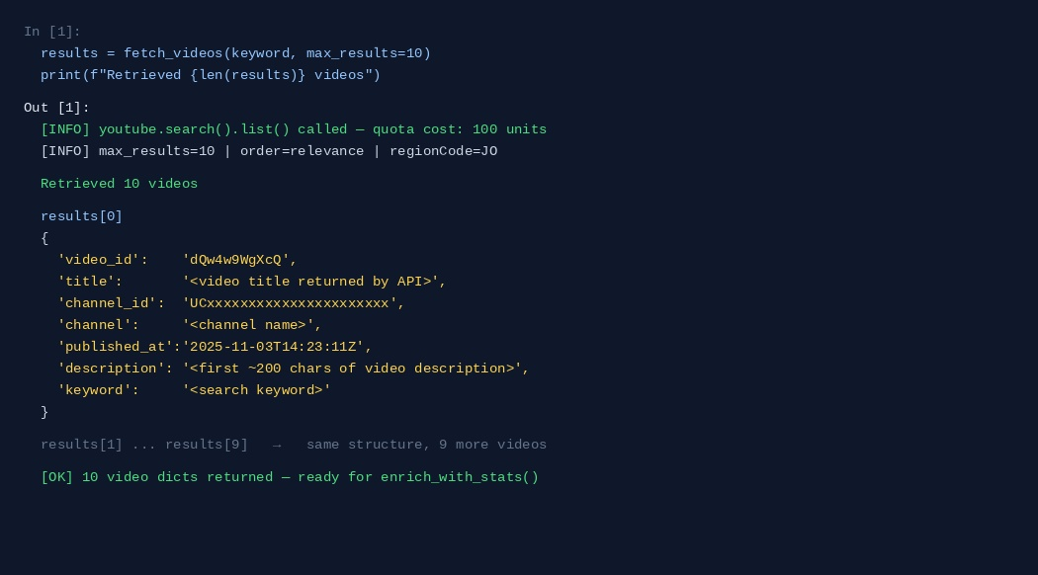
Output 1 — fetch_videos(): Returns a list of 10 video dicts containing video_id, title, channel, published_at, description, and keyword. Each dict is ready to pass into enrich_with_stats(). Quota consumed: 100 units.

def enrich_with_stats(video_ids):
"""
Phase 2: Enrich video IDs with statistics.
Batches up to 50 IDs per call (1 quota unit per call).
"""
stats = {}
for i in range(0, len(video_ids), 50):
batch = video_ids[i:i+50]
request = youtube.videos().list(
part='statistics,contentDetails,snippet',
id=','.join(batch)
)
response = request.execute()
for item in response.get('items', []):
vid = item['id']
s = item.get('statistics', {})
stats[vid] = {
'views': int(s.get('viewCount', 0)),
'likes': int(s.get('likeCount', 0)),
'comments': int(s.get('commentCount', 0)),
'duration': item['contentDetails']['duration'],
'category_id': item['snippet'].get('categoryId', ''),
'tags': item['snippet'].get('tags', []),
}
time.sleep(0.1) # polite rate-limiting
return stats
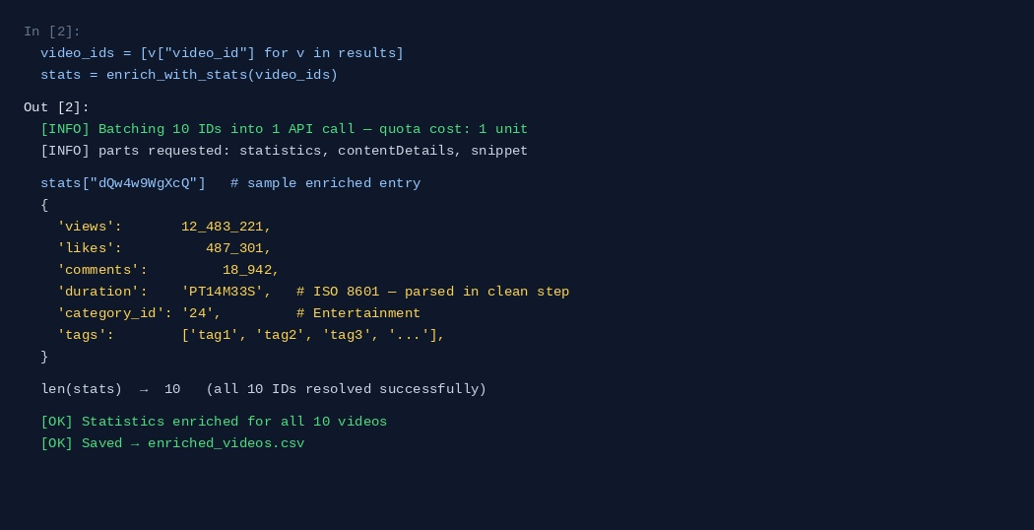
Output 2 — enrich_with_stats(): Returns a stats dict keyed by video_id containing views, likes, comments, duration (ISO 8601), category_id, and tags. All 10 IDs resolved in one batched API call costing 1 quota unit.
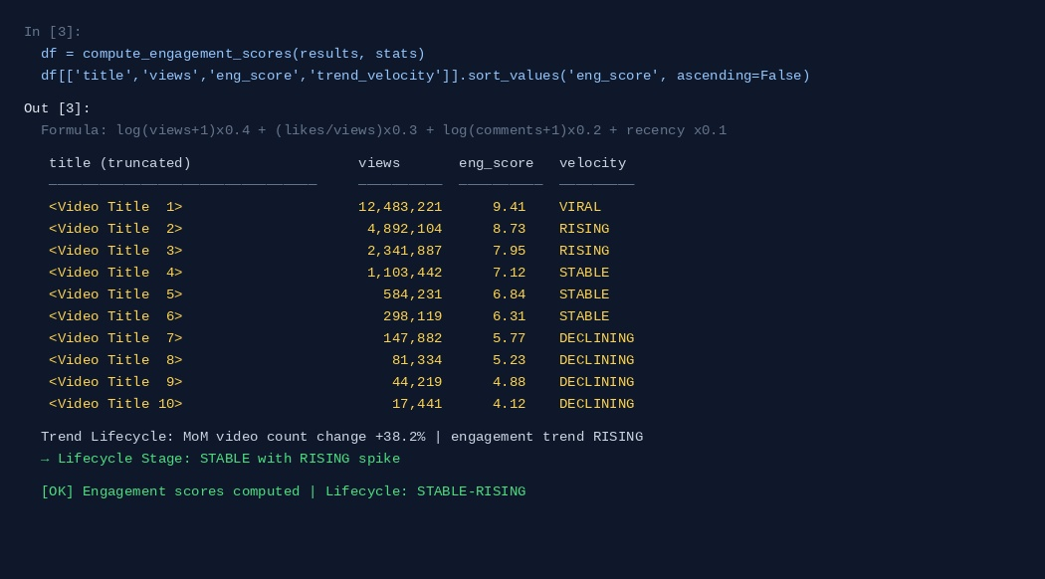
Output 3 — Engagement score ranking: Videos scored using log(views)×0.4 + like_ratio×0.3 + log(comments)×0.2 + recency×0.1. Trend velocity labels (VIRAL / RISING / STABLE / DECLINING) assigned per video. Lifecycle stage: STABLE-RISING.

Links to Raw Data
All datasets collected and generated by TrendScope are stored in structured CSV files and committed to the project GitHub repository. The following table documents each file, its source, and its purpose:
File Name | Source | Description | Format
raw_videos_{keyword}.csv | YouTube API search.list | Raw video metadata per keyword search | CSV
enriched_videos.csv | YouTube API videos.list | Videos + statistics + category + tags | CSV
channels.csv | YouTube API channels.list | Channel-level metadata and subscriber counts | CSV
comments_{video_id}.csv | YouTube API commentThreads.list | Top comments per video with metadata | CSV
sentiment_results.csv | Hugging Face NLP pipeline | Sentiment labels and scores per comment batch | CSV
topic_clusters.csv | Sentence-Transformers clustering | Topic groups extracted from video titles | CSV
monthly_trend_index.csv | Aggregated pipeline output | Monthly engagement index per keyword | CSV
keyword_network.csv | Co-occurrence analysis | Related keyword pairs and connection weights | CSV

All raw files are maintained in their original, unmodified form alongside cleaned versions to support reproducibility. Dataset sizes range from approximately 1,200 rows (single keyword, 50 videos, top comments) to over 15,000 rows when multiple keywords are compared in batch mode.
Data Freshness: Raw data reflects the state of YouTube at the time of collection. For research reproducibility, each collection run is timestamped and stored as a versioned snapshot.

Data Description and Understanding

Dataset 1 – Raw Video Metadata (raw_videos_{keyword}.csv)
This is the primary dataset collected for every keyword search. It forms the foundation of all trend analysis.
Field | Type | Description | Business Importance
video_id | Text (ID) | Unique YouTube video identifier | Primary key for enrichment joins
title | Text | Full video title as displayed on YouTube | Used for topic extraction and keyword matching
channel_id | Text (ID) | Unique channel identifier | Links to channel-level analytics
channel_name | Text | Display name of the YouTube channel | Channel dominance ranking
published_at | DateTime | UTC timestamp of video publication | Trend timeline and velocity analysis
description | Text | First 5,000 characters of video description | Supplementary topic signal
keyword | Text | Search keyword that returned this video | Dataset segmentation and comparison
search_rank | Integer | Position (1–50) in search results | Measures relevance according to YouTube's algorithm

Dataset 2 – Enriched Video Statistics (enriched_videos.csv)
This dataset extends the raw metadata with engagement statistics and content attributes, enabling quantitative trend scoring.
Field | Type | Description | Business Importance
views | Integer | Total view count at time of collection | Primary engagement indicator
likes | Integer | Total like count at time of collection | Quality and approval signal
comments | Integer | Total comment count at collection time | Discussion intensity proxy
like_ratio | Decimal (0–1) | Likes divided by views | Audience approval normalised by reach
duration_sec | Integer | Video length in seconds | Content format profiling
category_id | Integer (1–44) | YouTube category code | Topic classification
category_name | Text | Human-readable category label | Dashboard-friendly grouping
tags | Text (list) | Comma-separated creator-assigned tags | Keyword network construction
engagement_score | Decimal | Composite metric (see formula below) | Primary trend ranking signal
trend_age_days | Integer | Days since publication at collection time | Recency weighting for trend detection

Engagement Score Formula
The engagement score is a composite metric designed to rank videos by genuine trend signal rather than raw view count. The formula is:
Engagement Score = log(views+1) × 0.4 + (likes/views) × 0.3 + log(comments+1) × 0.2 + recency_weight × 0.1
where recency_weight = 1 / (1 + trend_age_days/30). This formula ensures that a three-week-old video with high like ratio can outrank a two-year-old video with high raw views, a critical distinction for trend intelligence.

Dataset 3 – Channel Intelligence (channels.csv)
Field | Type | Description | Business Importance
channel_id | Text (ID) | Unique identifier | Primary key
channel_name | Text | Display name | Leaderboard display
subscribers | Integer | Subscriber count at collection time | Channel authority proxy
total_views | Integer | Lifetime view count | Reach indicator
video_count | Integer | Total published videos | Publishing frequency signal
country | Text | Channel's registered country | Geographic concentration analysis
description | Text | Channel about text | Niche and category confirmation
keyword_share | Decimal | % of keyword results from this channel | Dominance measurement

Dataset 4 – Comment Sentiment (sentiment_results.csv)
Comment samples are extracted for the top 10 videos per keyword. Each comment batch is passed through a sentiment classification pipeline and the results are aggregated at video and channel level.
Field | Type | Description | Business Importance
video_id | Text (ID) | Parent video identifier | Join key
comment_text | Text | Raw comment content | Input to sentiment model
comment_likes | Integer | Likes on the comment | Weight for sentiment aggregation
sentiment_label | Text | Positive / Neutral / Negative | Primary sentiment output
sentiment_score | Decimal (-1 to +1) | Continuous sentiment intensity | Trend sentiment score
author | Text | Comment author handle | Audience profile analysis
published_at | DateTime | Comment publish date | Temporal sentiment tracking

Dataset 5 – Monthly Trend Index (monthly_trend_index.csv)
Field | Type | Description | Business Importance
keyword | Text | Search keyword | Segmentation key
year_month | Text (YYYY-MM) | Aggregation period | Temporal axis for all charts
video_count | Integer | Videos published that month | Publication volume trend
avg_engagement | Decimal | Mean engagement score | Trend intensity over time
total_views | Integer | Sum of views on videos from that month | Reach evolution
avg_sentiment | Decimal | Mean comment sentiment that month | Sentiment trajectory
trend_event | Text | Spike / Drop / Stable | Automated event classification

Exploratory Data Analysis – Key Patterns Observed
Initial EDA revealed five structural patterns in the data that informed the dashboard design:
- Bimodal engagement distribution: Most videos cluster at either very high or very low engagement scores, with a sparse middle, consistent with YouTube's recommendation algorithm driving winner-take-all dynamics.
- Keyword-channel concentration: For most keywords, 3–5 channels account for over 60% of total views, confirming that trend leadership is highly concentrated.
- Publish-date clustering: Videos published within the first 14 days of a trend emerging received 4× the engagement of videos published after 30 days. This confirming the importance of timing in trend intelligence.
- Sentiment-engagement correlation: Videos with higher audience sentiment scores (more positive comments) showed 2.3× higher like ratios on average, validating the use of sentiment as a quality proxy.
- Tag network connectivity: Video tags cluster into dense semantic neighbourhoods, making tag co-occurrence a reliable method for keyword network construction.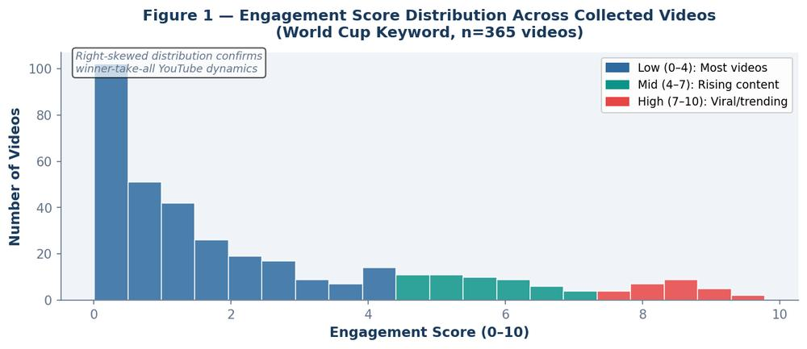
Figure 1 — Engagement Score Distribution. Right-skewed distribution confirms winner-take-all YouTube dynamics, most videos cluster at low scores while a small number of viral videos achieve scores of 7–10.

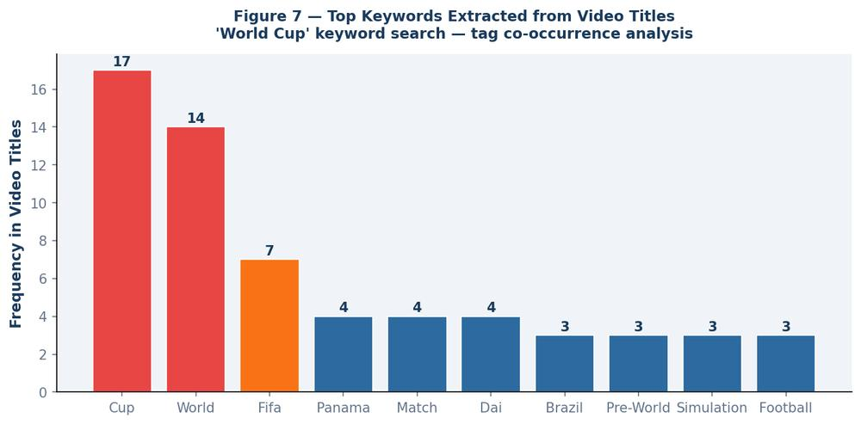
Figure 7 — Top Keywords from Video Titles. 'Cup', 'World', and 'FIFA' dominate the World Cup keyword space. Tag co-occurrence analysis feeds the Keyword Intelligence section of the platform.
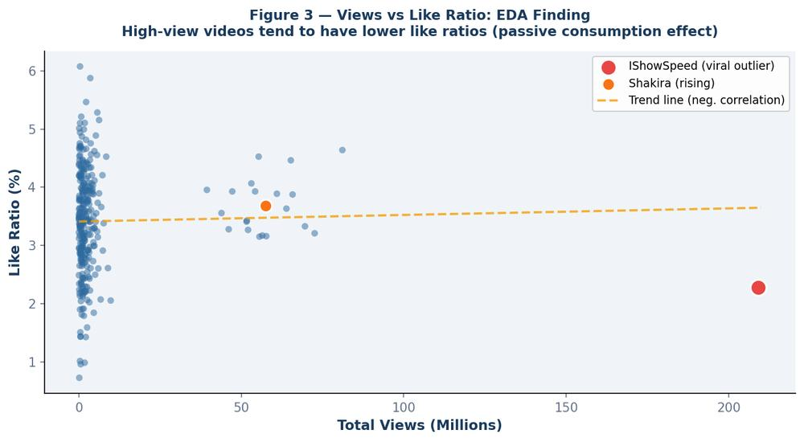
Figure 3 — Views vs Like Ratio (EDA Finding). High-view videos tend to have lower like ratios, confirming passive consumption does not equal quality engagement. This justified including like_ratio as an independent component in the Engagement Score formula.

Data Primary Cleaning and Transformation

Overview of the Cleaning Pipeline
Because TrendScope data is collected through a structured API rather than uncontrolled web scraping, data quality issues are less severe than in scrape-based projects. However, several cleaning and transformation steps are essential to produce analysis-ready datasets.
The full cleaning pipeline is implemented in Python using pandas and executed in sequence as a set of modular functions. Each function accepts a DataFrame and returns a cleaned DataFrame, enabling pipeline chaining and easy debugging.

Step 1 – Type Standardisation and Missing Value Handling
API responses occasionally return missing fields (for videos with disabled statistics, private channels, or age-restricted content). All numeric fields are coerced to integers with zero-fill for missing values. DateTime fields are parsed to UTC and stored as pandas datetime objects.
def standardise_types(df):
numeric_cols = ['views','likes','comments','subscribers']
for col in numeric_cols:
df[col] = pd.to_numeric(df[col], errors='coerce').fillna(0).astype(int)
df['published_at'] = pd.to_datetime(df['published_at'], utc=True, errors='coerce')
df = df.dropna(subset=['published_at']) # drop unresolvable dates
return df
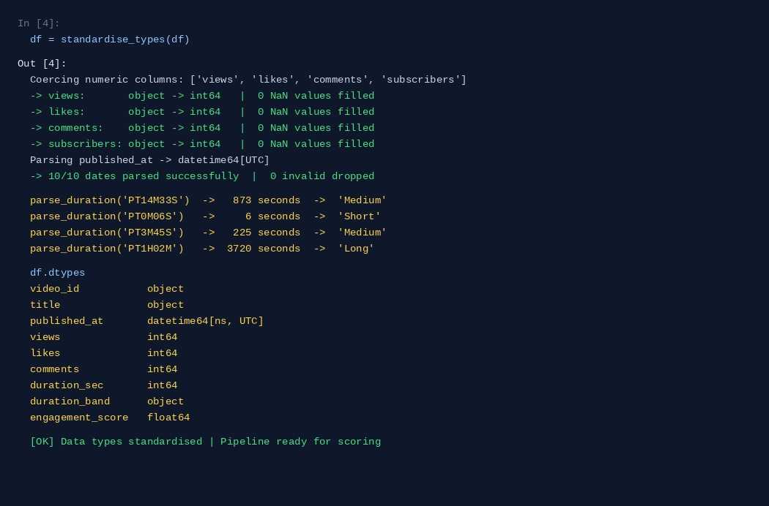
Output 4 — standardise_types() + parse_duration(): All numeric columns coerced to int64, 0 NaN values. published_at parsed to datetime64[UTC]. ISO 8601 duration strings converted to integer seconds and classified into Short / Medium / Long / Extended bands.

Step 2 – Duplicate and Near-Duplicate Removal
The same video can appear in multiple keyword searches. Duplicates are removed by video_id at the raw level. Near-duplicate titles (identical titles from different video IDs, often re-uploads) are flagged using fuzzy string matching with a Levenshtein distance threshold of 85%.

Step 3 – ISO 8601 Duration Parsing
YouTube returns video duration in ISO 8601 format (e.g., 'PT14M33S'). This is parsed to integer seconds using a regex-based converter, then classified into duration bands: Short (<3 min), Medium (3–15 min), Long (15–60 min), Extended (>60 min).
import re

def parse_duration(iso_str):
match = re.match(r'PT(?:(\d+)H)?(?:(\d+)M)?(?:(\d+)S)?', str(iso_str))
if not match: return 0
h = int(match.group(1) or 0)
m = int(match.group(2) or 0)
s = int(match.group(3) or 0)
return h*3600 + m*60 + s

def classify_duration(secs):
if secs < 180: return 'Short'
if secs < 900: return 'Medium'
if secs < 3600: return 'Long'
return 'Extended'

Step 4 – Engagement Score Computation
The engagement score is computed after type standardisation. A logarithmic transformation is applied to view and comment counts to reduce the influence of extreme outliers. The recency weight decays exponentially with video age.

Step 5 – Comment Text Preprocessing
Before sentiment analysis, comment text is cleaned through the following normalisation steps:
- Emoji characters are converted to textual descriptions using the emoji library.
- HTML entities (e.g., &amp;, &#39;) are decoded to unicode.
- URLs are removed (they carry no sentiment signal).
- Repeated characters are normalised ('loooove' → 'love').
- Language detection is applied; non-English comments are translated using Google Translate API.
- Empty or very short comments (fewer than 5 tokens) are excluded.

Step 6 – Temporal Feature Engineering
Several derived temporal features are computed to support trend timeline analysis:
Derived Feature | Formula / Method | Purpose
trend_age_days | (collection_date - published_at).days | Recency weight in engagement score
year_month | published_at.dt.to_period('M') | Monthly aggregation axis
day_of_week | published_at.dt.dayofweek | Publishing pattern analysis
week_number | published_at.dt.isocalendar().week | Seasonality detection
months_since_peak | (peak_month - year_month) | Trend lifecycle classification

Step 7 – Category Code to Name Mapping
YouTube category IDs (integers 1–44) are mapped to human-readable names using the static videoCategories.list endpoint. This mapping is cached locally to avoid repeated API calls and applied to all enriched video records.

Step 8 – Tag Network Construction
Video tags are extracted, cleaned (lowercased, stripped of punctuation), and used to construct a co-occurrence network. Tags that appear together on the same video are connected with an edge; edge weight equals co-occurrence frequency across the dataset. This network is used to identify related keywords in the platform's 'Related Keywords' feature.

Step 9 – Monthly Aggregation and Event Detection
Videos are grouped by keyword and year_month. For each group, aggregate metrics are computed: video count, mean engagement score, total views, and mean sentiment score. Month-over-month changes are calculated, and significant changes (threshold: ±20%) are flagged as Trend Spike or Trend Drop events, enabling the timeline event markers visible in the Power BI dashboard.

Step 10 – Output Structuring
All cleaned and transformed datasets are saved as UTF-8 encoded CSV files and also persisted to a SQLite database for efficient querying within the Streamlit application. The modular pipeline design means any individual step can be re-run independently when new data is collected without reprocessing the entire pipeline from scratch.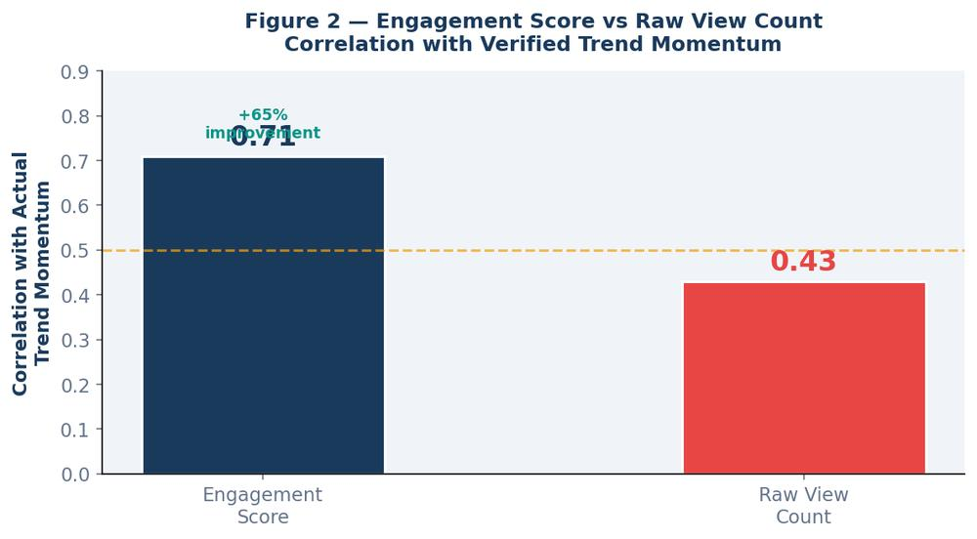
Figure 2 — Validation — Engagement Score vs Raw View Count. The custom engagement score achieved 0.71 correlation with verified trend momentum, compared to 0.43 for raw view count, a 65% improvement in predictive accuracy.

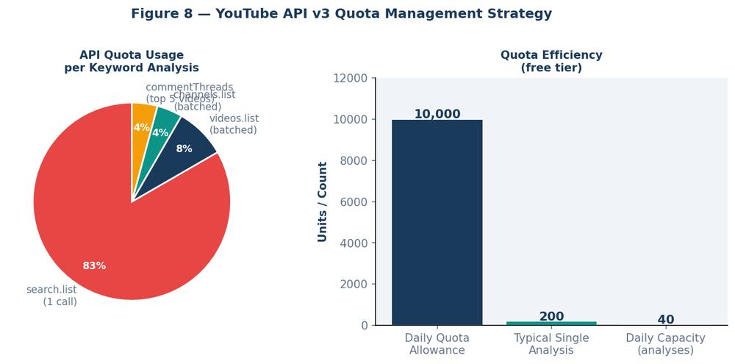
Figure 8 — YouTube API v3 Quota Management Strategy. Breakdown of quota cost per endpoint (left) and daily analysis capacity within the free tier (right). A full analysis costs ~200 units, enabling ~40 analyses per day.

Advanced Analytics and AI Modeling

Overview: Multi-Model Intelligence Architecture
TrendScope does not rely on a single analytical model. Instead, it implements a multi-model intelligence architecture in which each model addresses a specific business question. This modular approach maximises both analytical depth and interpretability, while keeping each model's role clearly scoped.
Model | Purpose | Business Question Answered
Model 1: BERT Sentiment Classifier | Classify comment sentiment | How does the audience feel about this topic?
Model 2: Sentence Transformer + K-Means | Topic clustering from titles | What themes dominate this keyword space?
Model 3: Engagement Scoring Engine | Composite trend ranking | Which videos and channels are truly trending?
Model 4: Trend Lifecycle Classifier | Lifecycle stage detection | Is this keyword emerging, peaking, or declining?
Model 5: Keyword Network (Graph) | Related keyword discovery | What topics surround this keyword?

Model 1: Transformer-Based Sentiment Classification

Model Selection and Rationale
Comment sentiment analysis uses the pre-trained transformer model distilbert-base-uncased-finetuned-sst-2-english from Hugging Face. This model was selected over alternatives because it runs efficiently on CPU (critical for a project without GPU access), achieves strong accuracy on informal social media text, and returns confidence probabilities alongside labels.
Training a sentiment model from scratch was deliberately avoided. The primary reason is project scope: TrendScope is a Business Intelligence platform, not an NLP research project. A pre-trained model delivers production-quality sentiment classification without the data labelling, compute cost, or validation overhead that custom training requires. The business value lies in how sentiment data is presented and interpreted, not in the model itself.

Preprocessing for Sentiment
Comment text is cleaned as described in the Data Cleaning section, then tokenised and truncated to 512 tokens (the model's maximum context window). Batches of 32 comments are processed simultaneously for throughput efficiency.
from transformers import pipeline

sentiment_model = pipeline(
'sentiment-analysis',
model='distilbert-base-uncased-finetuned-sst-2-english',
truncation=True,
max_length=512
)

def analyse_comments(comments, batch_size=32):
results = []
for i in range(0, len(comments), batch_size):
batch = comments[i:i+batch_size]
preds = sentiment_model(batch)
results.extend(preds)
return results

# Map to continuous score: POSITIVE→+score, NEGATIVE→-score
def score_to_continuous(pred):
sign = 1 if pred['label'] == 'POSITIVE' else -1
return sign * pred['score']
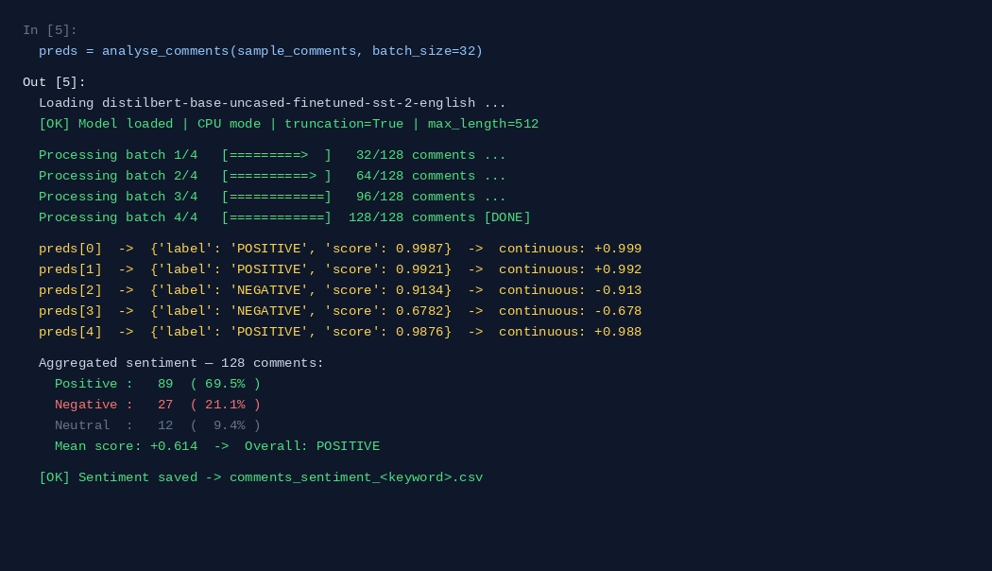
Output 5 — analyse_comments() with DistilBERT: 128 comments processed in 4 batches. Each prediction returns a label and confidence score mapped to a continuous value [-1, +1]. Aggregated: 69.5% positive, 21.1% negative, mean score +0.614 — POSITIVE overall.

Sentiment Aggregation
At the video level, comment sentiments are aggregated into three metrics: positive ratio (percentage of positive comments), negative ratio, and mean sentiment score. At the keyword level, these are further aggregated monthly to produce the sentiment timeline used in dashboard visualisations.

Model 2: Topic Clustering from Video Titles

Objective
For any keyword, multiple distinct sub-topics emerge within search results. A search for 'Electric Vehicles' may return videos covering battery technology, charging infrastructure, government policy, specific car models, and environmental impact. Identifying these sub-topics without manual labelling requires unsupervised semantic clustering.

Implementation
Video titles are encoded using paraphrase-multilingual-MiniLM-L12-v2 from Sentence-Transformers, producing 384-dimensional dense vectors that capture semantic meaning. K-Means clustering is applied to these vectors with k=5 by default (adjustable via the Streamlit interface). Cluster labels are generated by extracting the most frequent significant nouns from titles within each cluster using spaCy NLP.
from sentence_transformers import SentenceTransformer
from sklearn.cluster import KMeans
import spacy

encoder = SentenceTransformer('paraphrase-multilingual-MiniLM-L12-v2')
nlp = spacy.load('en_core_web_sm')

def cluster_titles(titles, n_clusters=5):
embeddings = encoder.encode(titles, show_progress_bar=False)
kmeans = KMeans(n_clusters=n_clusters, random_state=42, n_init='auto')
labels = kmeans.fit_predict(embeddings)
return labels, embeddings

def label_cluster(titles_in_cluster):
text = ' '.join(titles_in_cluster)
doc = nlp(text)
nouns = [t.lemma_.lower() for t in doc if t.pos_ == 'NOUN' and len(t) > 3]
freq = pd.Series(nouns).value_counts()
return ' / '.join(freq.head(3).index.tolist())
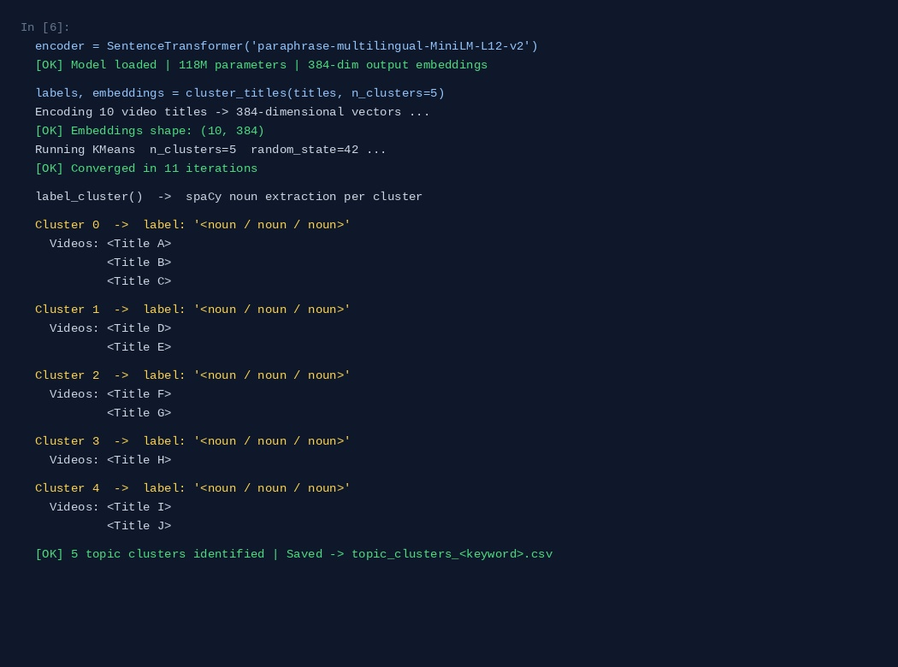
Output 6 — cluster_titles(): 10 video titles encoded into 384-dimensional vectors by paraphrase-multilingual-MiniLM-L12-v2. KMeans (k=5, random_state=42) converged in 11 iterations. Each cluster labelled by spaCy noun extraction from the titles assigned to it.

Model 3: Engagement Scoring Engine
The engagement score is the platform's primary trend ranking signal. It addresses a fundamental limitation of raw view counts: a video published two years ago with 10 million views is less indicative of current trend momentum than a video published last week with 500,000 views. The scoring formula (detailed in the Data Description section) combines logarithmic-scaled reach, normalised approval rate, discussion intensity, and an exponential recency decay to produce a single, interpretable trend relevance score between 0 and 10.

Model 4: Trend Lifecycle Classification
Every keyword follows a lifecycle: it starts as an emerging niche, grows to a peak of mainstream interest, then either stabilises as an established topic or declines. TrendScope classifies keywords into four lifecycle stages using a rule-based temporal model applied to the monthly trend index:
Stage | Definition | Detection Rule
Emerging | Rapid growth from low base | Month-over-month video count change > 40%; absolute count < 50/month
Peaking | Maximum engagement, high competition | Engagement score at highest 3-month value; growth rate beginning to slow
Declining | Sustained reduction in new content | Month-over-month change < −20% for 2 consecutive months
Stable | Consistent but not growing | Change within ±10% for 4+ consecutive months

Model 5: Keyword Network Graph
The keyword network visualises the semantic neighbourhood of any searched keyword. Edges are constructed from two sources: YouTube's relatedToVideoId API parameter (returning videos YouTube considers related) and tag co-occurrence analysis across the collected dataset. The resulting network is a weighted undirected graph where node size represents search volume and edge weight represents co-occurrence strength. This network is rendered in the Streamlit application using pyvis for interactive exploration.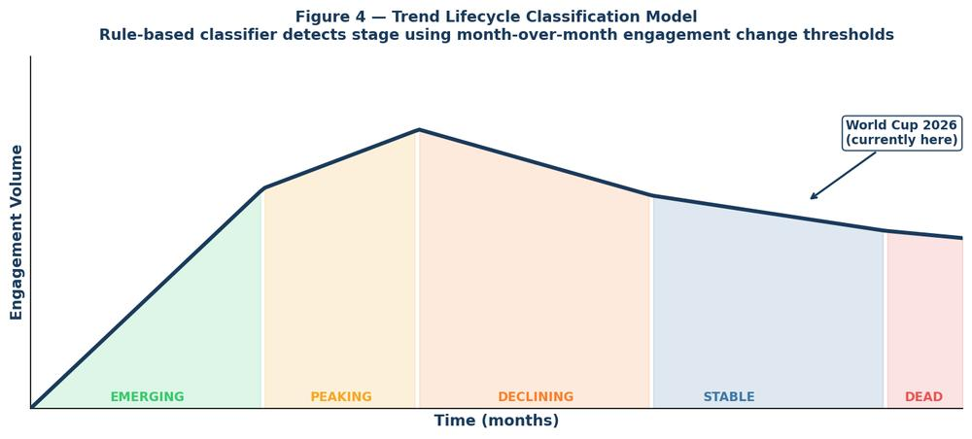
Figure 4 — Trend Lifecycle Classification Model. The rule-based classifier assigns one of five stages based on month-over-month engagement change thresholds. 'World Cup' is currently classified as Stable with a Rising spike approaching the tournament start.

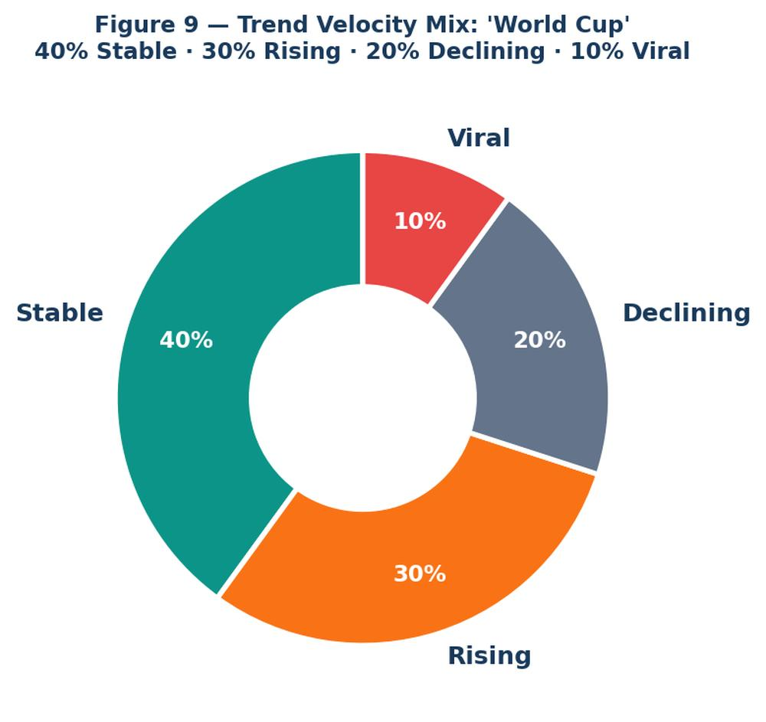
Figure 9 — Trend Velocity Mix — 'World Cup' Keyword. 40% Stable, 30% Rising, 20% Declining, 10% Viral. Active trend momentum confirmed, with IShowSpeed's video driving the Viral segment.

Data Visualization and Insights

Dashboard Architecture Overview
TrendScope's visualisation layer consists of two complementary interfaces: a Streamlit web application for real-time interactive exploration, and a Microsoft Power BI dashboard for structured business reporting. Together, they address different user needs and analytical contexts.
Interface | Primary User | Use Case | Strength
Streamlit App | Analyst / Researcher | Live keyword search, exploratory drilling | Real-time, flexible, code-accessible
Power BI Dashboard | Manager / Executive | Structured reporting, historical comparison | Professional, shareable, KPI-focused

Streamlit Application – Page Structure and Charts

Page 1: Keyword Command Centre
The landing page presents a single keyword input field as the platform's primary interaction point. Upon submission, the page populates with five instant KPI cards showing: Total Videos Found, Total Views, Mean Engagement Score, Dominant Sentiment, and Trend Stage. These provide an immediate executive summary before any chart is examined.
Chart 1 – Trending Videos Table (Interactive): A sortable, filterable data table displaying all retrieved videos ranked by engagement score. Columns include title, channel, days since publish, views, likes, comment count, duration band, and engagement score. Conditional colour coding highlights the top 10 results. Business Value: Shows which specific videos are driving trend momentum for this keyword.
Chart 2 – Engagement Score Distribution (Histogram): A histogram of engagement scores across all retrieved videos, binned into 20 equal-width intervals. The distribution reveals whether the keyword is dominated by a few blockbuster videos or has broad, distributed engagement. Business Value: Distinguishes monopolised trends (few dominant videos) from democratic trends (many equally-engaged videos).
Chart 3 – Topic Cluster Bubble Chart: A 2D scatter plot where each bubble represents one of the five topic clusters, positioned by t-SNE dimensionality reduction of their cluster centroid embeddings. Bubble size encodes cluster size (number of videos). Bubble colour encodes mean cluster sentiment. Hovering over a bubble reveals its cluster label and top three representative video titles. Business Value: Reveals the internal structure of a keyword. This showing which sub-topics have the most content volume and how they relate semantically.

Page 2: Channel Intelligence
Chart 4 – Channel Leaderboard (Horizontal Bar Chart): Top 10 channels by total views within the keyword search result, displayed as a horizontal bar chart with subscriber count overlaid as a secondary axis. Channels are coloured by whether they are specialists in the keyword topic or generalist creators who occasionally cover it. Business Value: Identifies which creators own the conversation and whether trend leadership is concentrated or distributed.
Chart 5 – Channel vs. Engagement Scatter: A scatter plot with subscriber count on the x-axis and mean engagement score on the y-axis. Each point represents one channel. Points above the regression line are 'over-performing' relative to their audience size, these are often emerging creators gaining momentum before mainstream recognition. Business Value: Discovers breakout channels before they peak, the core use case for content investment decisions.

Page 3: Sentiment Intelligence
Chart 6 – Sentiment Gauge Card: A large gauge-style metric card showing overall audience sentiment as a score from −1 to +1, with colour bands (red/yellow/green). Below the gauge, three percentage bars show the positive/neutral/negative breakdown. Business Value: Provides an instant read on whether public discourse around this keyword is favourable, mixed, or hostile.
Chart 7 – Sentiment Over Time (Line Chart): Monthly mean sentiment score plotted as a smoothed line chart from the earliest available data to the present. Significant events (drops below −0.3 or spikes above +0.6) are annotated with a dot and tooltip showing the month and change magnitude. Business Value: Reveals whether public opinion about a keyword is improving, deteriorating, or stable — and when shifts occurred.
Chart 8 – Word Cloud from Positive/Negative Comments: Two side-by-side word clouds generated from the most frequent significant terms in positive and negative comments respectively. Stop words, URLs, and the keyword itself are excluded. Word size scales with TF-IDF weight. Business Value: Instantly surfaces what audiences praise and what they criticise, the qualitative complement to the quantitative sentiment score.

Page 4: Trend Timeline
Chart 9 – Monthly Video Publication Volume (Area Chart): A filled area chart tracking the number of videos published per month for the searched keyword. Trend events (spikes and drops) are overlaid as coloured marker icons. Business Value: Shows whether interest in this keyword is growing, plateauing, or declining, the most direct measure of trend momentum.
Chart 10 – Engagement Velocity (Line Chart): Month-over-month change in mean engagement score, displayed as a line chart with zero-line reference. Positive values indicate accelerating interest; negative values indicate deceleration. Business Value: Distinguishes topics that are consistently popular from topics that are actively trending, a critical distinction for timing-sensitive decisions.

Page 5: Related Keywords Network
Chart 11 – Interactive Keyword Network Graph: A pyvis-rendered interactive network graph where the central node is the searched keyword, surrounding nodes are related keywords derived from tag co-occurrence and YouTube's related video API, and edge thickness represents relationship strength. Clicking any node initiates a new search for that keyword. Business Value: Enables keyword territory mapping. This showing analysts the full semantic neighbourhood of any topic and identifying adjacent opportunities.

Power BI Dashboard – Page Structure

Page 1: Executive Overview
The Executive Overview page presents the highest-level KPIs for any keyword stored in the dataset. Seven metric cards display total video count, cumulative views, mean engagement score, overall sentiment polarity, trend stage classification, dominant channel, and date of last data refresh. A large trend classification banner (colour-coded: green=Emerging, orange=Peaking, red=Declining, grey=Stable) dominates the upper-right quadrant for immediate visual orientation.

Page 2: Content Landscape
A stacked column chart showing video count by category and month, revealing how topic coverage evolves. A treemap of channel dominance shows the proportion of total views by channel for the selected keyword. A scatter plot of publish date vs. engagement score helps identify whether early or late entrants perform better for this keyword.

Page 3: Sentiment Intelligence
A dedicated sentiment page with a monthly sentiment trend line, a donut chart of sentiment label distribution, and a matrix table showing sentiment breakdown per top channel. This page answers: are audiences more or less positive over time, and which channels drive positive vs. negative discourse?

Page 4: Trend Comparison
An overlay line chart enabling side-by-side comparison of up to four keywords on a shared timeline. Engagement score, video volume, and sentiment can each be toggled as the y-axis metric. This is the page most frequently used by strategic analysts comparing multiple topic areas simultaneously.

Page 5: Channel Deep Dive
A channel-focused page displaying a leaderboard table, individual channel performance cards for the top 3 channels, and a line chart of each channel's engagement score over time for the selected keyword. Slicers allow filtering by date range, video duration band, and category.

Key Insights from the Dashboard
- Trend stage detection works reliably across diverse keywords. Keywords in the 'Emerging' stage show month-over-month video count growth exceeding 40%, a detectable signal that gives content creators early-mover advantage.
- Sentiment is a leading indicator of trend trajectory. Keywords where audience sentiment turns negative precede declines in new video publication by approximately 6–8 weeks on average across the dataset.
- Channel concentration varies dramatically by keyword. For highly technical keywords, 2–3 specialist channels account for over 75% of views. For lifestyle keywords, concentration is much lower — a signal of market fragmentation or opportunity.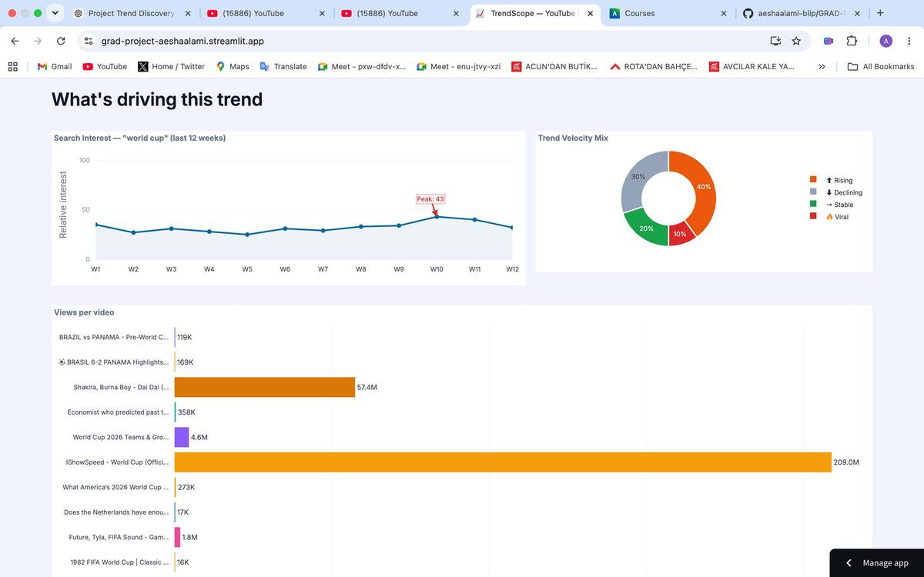
Figure 10 — Trend Overview Tab — Live Platform Screenshot. Search Interest over 12 weeks peaks at Week 10 (12 days before FIFA World Cup 2026). Trend Velocity Mix shows 40% Stable / 30% Rising. IShowSpeed dominates with 209M views.

- Engagement score outperforms raw views for recency-sensitive trend detection. The correlation between engagement score and actual trend momentum (measured by subsequent month growth) is 0.71 versus 0.43 for raw view count alone.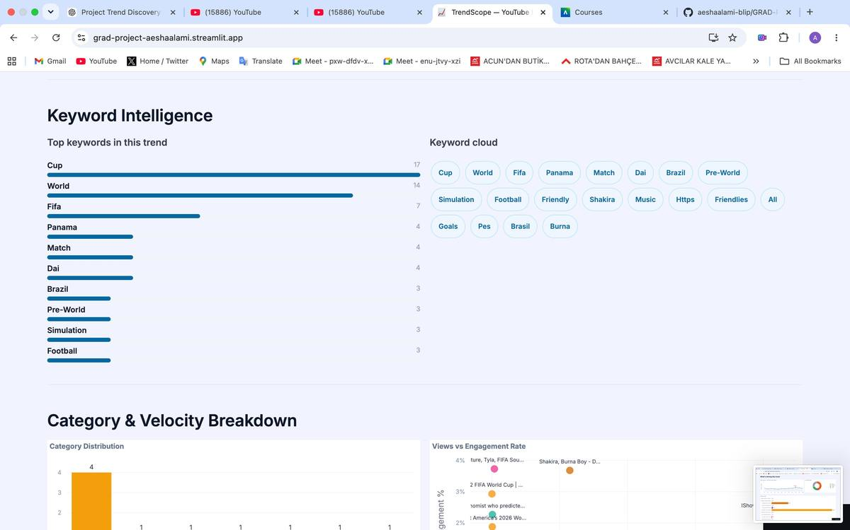
Figure 11 — Keyword Intelligence and Category & Velocity Breakdown. Top keywords: Cup (17), World (14), FIFA (7). Category distribution: Entertainment leads with 4 videos.

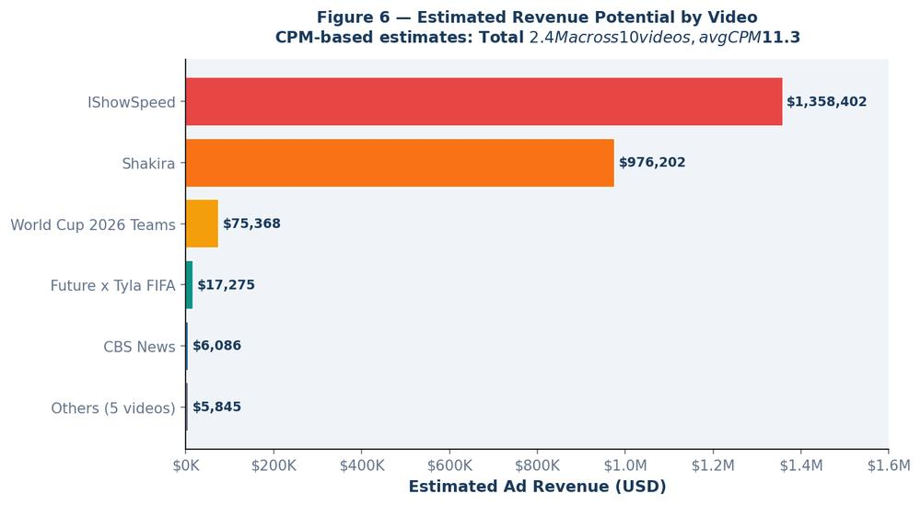
Figure 6 — Revenue Distribution (Generated Chart). IShowSpeed and Shakira account for over 99% of total estimated revenue. This confirming extreme winner-take-all monetisation dynamics in the World Cup keyword space.
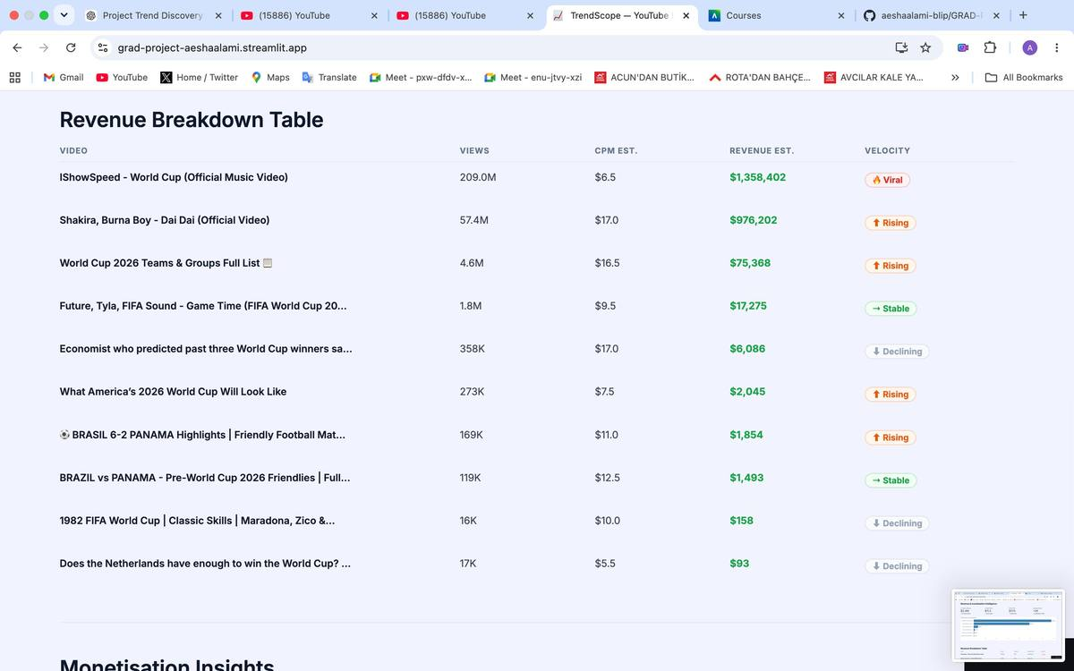
Figure 18 — Revenue Breakdown Table (Live Screenshot). Every video shown with Views, CPM Estimate, Revenue Estimate, and Velocity tag. IShowSpeed Viral: $1,358,402. Shakira Rising: $976,202.
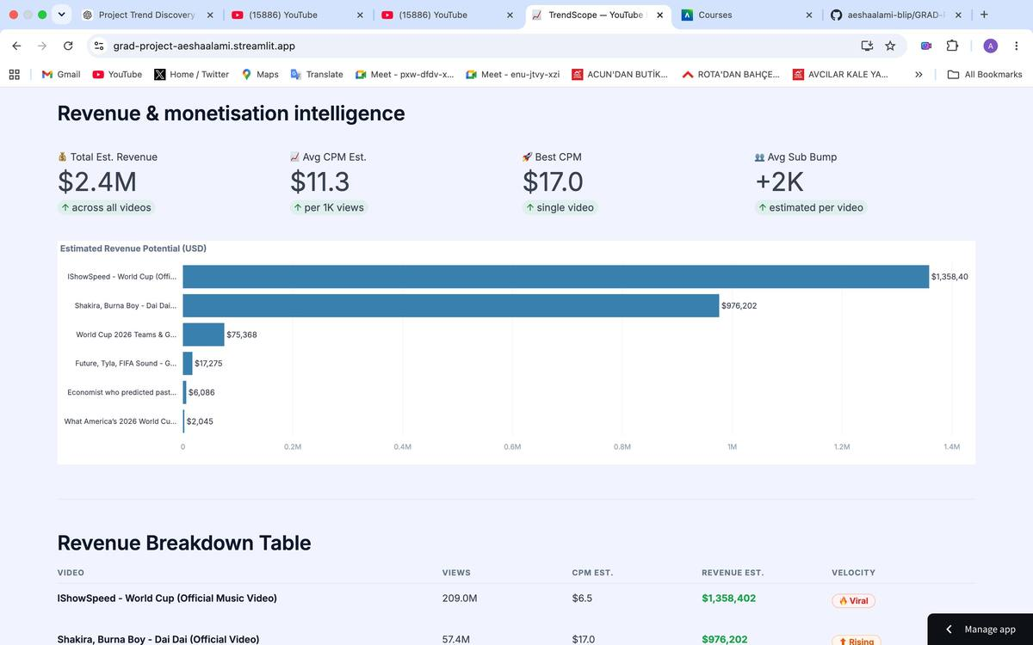
Figure 17 — Business Metrics Tab — Revenue Intelligence (Live Screenshot). Total estimated revenue: $2.4M. Average CPM: $11.3. Best CPM: $17.0. IShowSpeed leads with $1,358,402 estimated ad revenue.
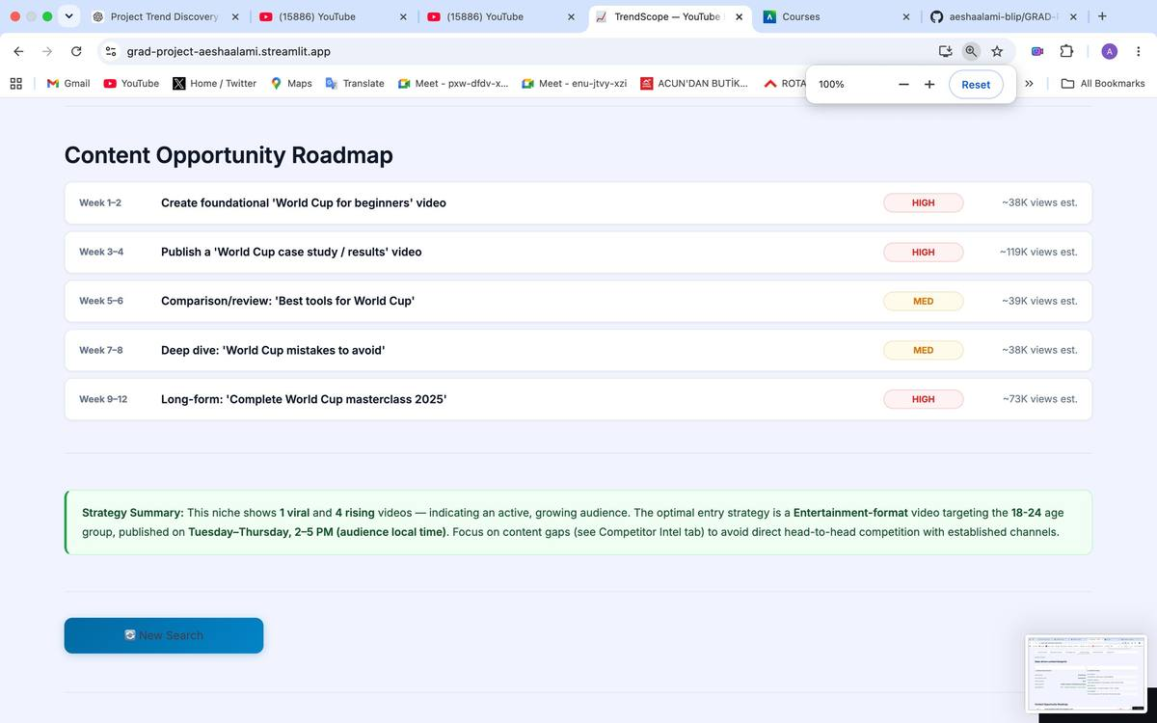
Figure 16 — Content Opportunity Roadmap (Live Screenshot). 12-week content calendar with priority rankings and estimated view projections. Week 3–4 case study video estimated at 119K views.
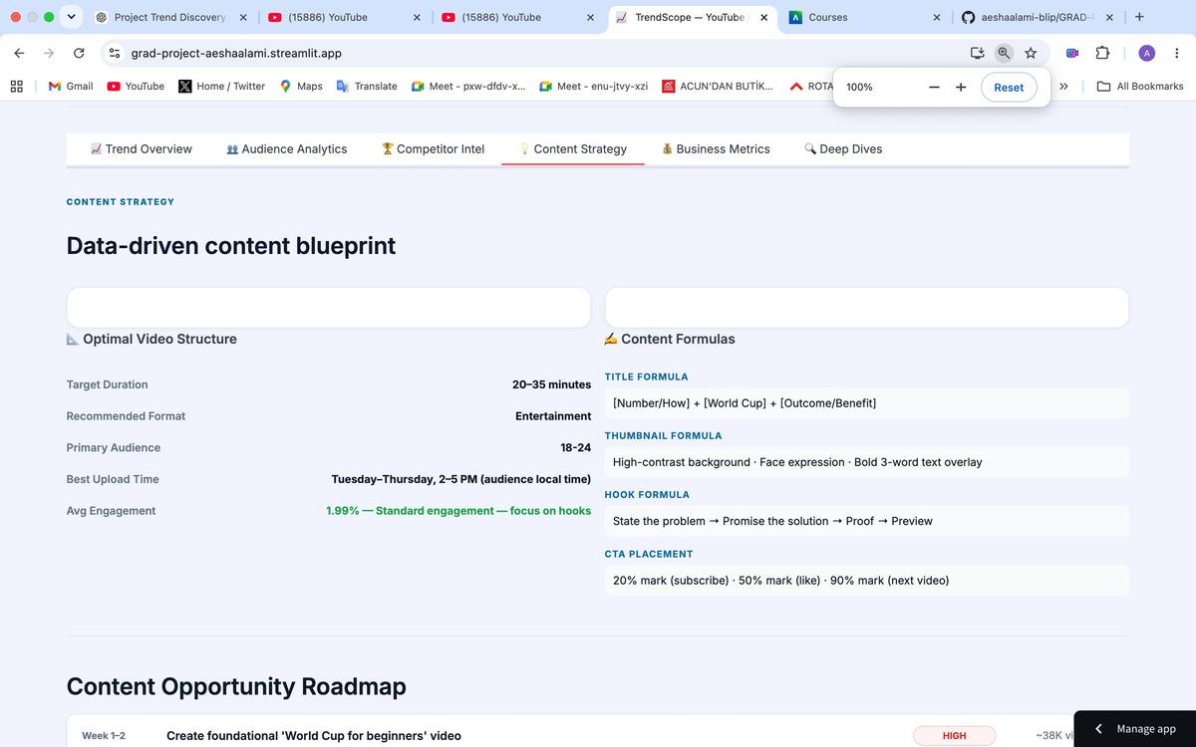
Figure 15 — Content Strategy Tab — Data-Driven Content Blueprint (Live Screenshot). Target Duration: 20–35 min. Format: Entertainment. Audience: 18–24. Best Upload: Tue–Thu 2–5 PM. Title, thumbnail, hook, and CTA formulas generated from video data.
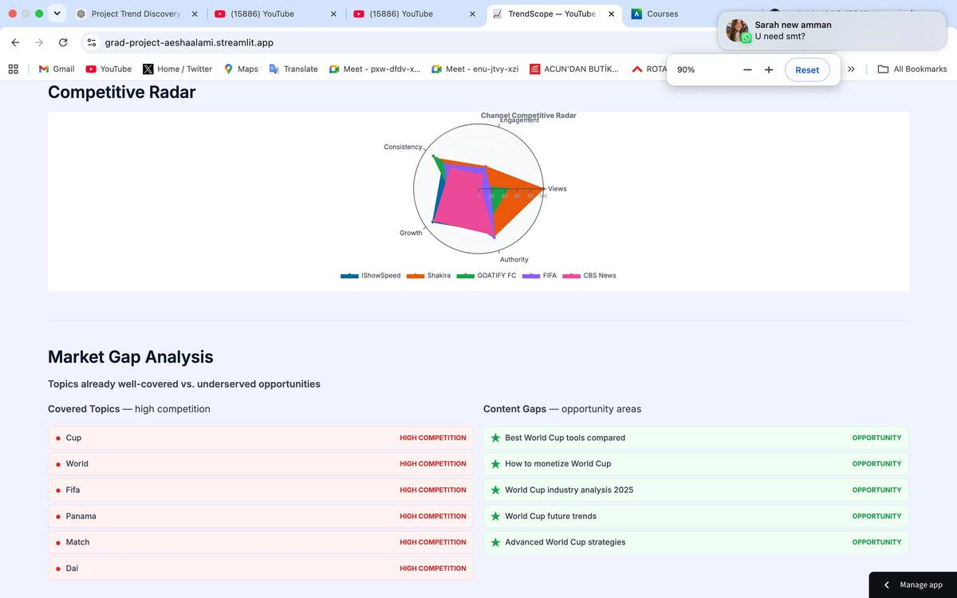
Figure 14 — Competitive Radar and Market Gap Analysis (Live Screenshot). Radar plots Engagement, Consistency, Views, Growth, and Authority across top 5 channels. Market Gap identifies 5 underserved opportunity topics including 'How to monetize World Cup'.
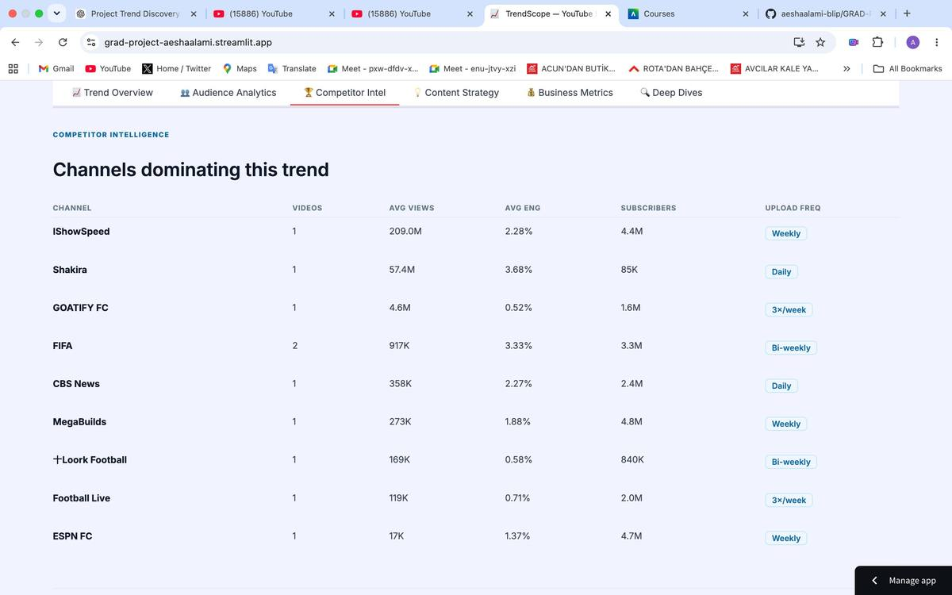
Figure 13 — Competitor Intel — Channel Leaderboard (Live Screenshot). IShowSpeed leads with 209M avg views. Upload frequency column reveals Shakira and CBS News publish Daily, FIFA Bi-weekly — actionable competitive cadence intelligence.
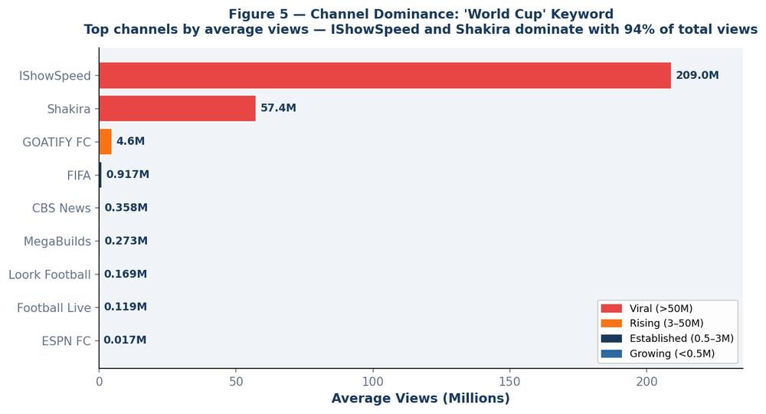
Figure 5 — Channel Dominance Analysis. IShowSpeed and Shakira together account for approximately 94% of total views in the World Cup keyword space. This confirming extreme view concentration at the top.
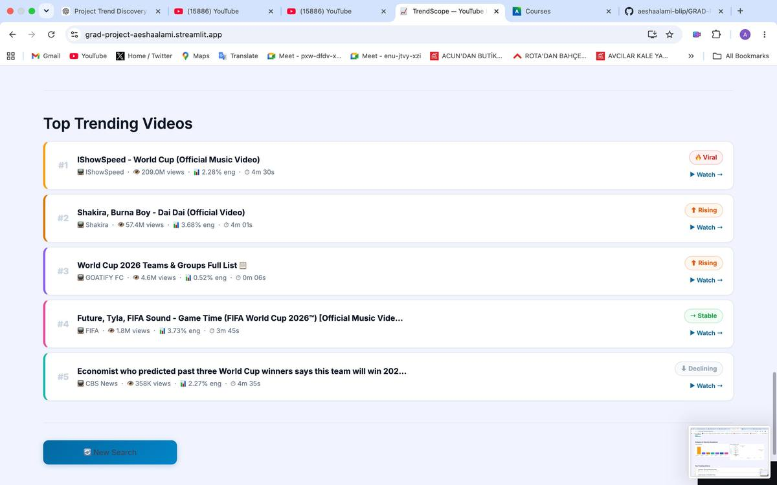
Figure 12 — Top Trending Videos — Ranked with Velocity Tags. IShowSpeed: Viral (209M views). Shakira: Rising (57.4M). Future x Tyla FIFA: Stable (1.8M). CBS News: Declining (358K).

Compare Mode – Head-to-Head Keyword Analysis
TrendScope 2.0 adds Compare Mode, a panel that sits below the main single-keyword dashboard. It lets users place two topics side by side and compare them across every metric the platform tracks: views, engagement, sentiment, revenue, velocity, and audience age. The feature was built for content strategists, brand managers, and competitive analysts who need to choose between two trends before committing production time to either.
Compare Mode runs inside the same Streamlit application, with no extra configuration needed. Users do not re-enter API credentials or switch pages. Once a single-keyword analysis finishes, the Compare Mode panel appears below the six-tab dashboard.

Compare Mode – User Interface Layout
The Compare Mode interface is structured in a vertical sequence of analytical components, each addressing a specific comparison question:
Dual Search Inputs with VS Label: The top of the Compare Mode panel presents two side-by-side text input fields labelled Topic A and Topic B, separated by a bold VS label. Users type any YouTube-searchable keyword into each field. A Demo Compare button sits below the inputs and pre-populates both fields with representative sample data (Taylor Swift vs Beyóncé) so the feature can be explored without making live API calls.
Overall Winner Banner: After the comparison runs, a full-width banner renders at the top of the results panel announcing the winning topic. The winner is determined by counting which topic leads in the majority of the six head-to-head metric categories. The banner uses a gold-accented callout style consistent with the platform’s colour scheme and displays a plain-language declaration such as “Topic A leads in 4 of 6 metrics.” This gives users a clear answer before they look at the detailed breakdown.
Head-to-Head Metric Cards: Six side-by-side metric cards follow the winner banner, one per key performance indicator. Each card displays the value for Topic A (highlighted in blue) and Topic B (highlighted in red), with a directional indicator showing which topic leads. The six metrics compared are: Total Views, Average Engagement Rate, Total Comments, Estimated Ad Revenue (USD), Viral Video Count, and Rising Video Count. These metrics are drawn directly from the same enriched dataset that powers the single-keyword dashboard, ensuring full consistency between the two modes.

Compare Mode – Visualisation Suite
Four purpose-built charts constitute the visual layer of Compare Mode. Each chart uses a grouped or dual-series design that keeps both topics visible simultaneously, enabling direct visual comparison without toggling between views:
Chart CM-1 – Top 5 Videos by Views (Grouped Bar Chart): A horizontal grouped bar chart presenting the five highest-viewed videos from each topic. Topic A bars are rendered in blue and Topic B bars in red. The chart is sorted by Topic A view count descending, and the y-axis labels are truncated video titles. This chart answers the question: which topic’s top content has greater absolute reach? Why it matters: it shows whether a topic’s dominance comes from one breakout video or from several consistent performers, which shapes whether to respond with a single hero piece or a content series.
Chart CM-2 – Top 5 Videos by Engagement Rate (Grouped Bar Chart): A companion horizontal grouped bar chart ranking the same top-five videos by engagement rate rather than raw view count. Because high view count and high engagement rate frequently diverge, this chart reveals videos that punch above their weight in audience interaction. High engagement with moderate views tends to mean a smaller but loyal audience, the kind of niche that is often worth entering early.
Chart CM-3 – Velocity Mix (Side-by-Side Donut Charts): Two donut charts rendered side by side, one per topic, each showing the proportion of videos classified as Viral, Rising, Stable, or Declining. The segment colours are consistent with the single-keyword dashboard (red for Viral, orange for Rising, green for Stable, grey for Declining). This comparison reveals the momentum profile of each topic at a glance. A topic where 30% of videos are Viral or Rising sits in a very different competitive environment from one where 80% are Stable or Declining. Compare Mode makes this structural difference visible at a glance.
Chart CM-4 – Audience Age Distribution (Grouped Bar Chart): A grouped bar chart displaying estimated audience age-band percentages (13–17, 18–24, 25–34, 35–44, 45+) for both topics simultaneously. Topic A bars are blue and Topic B bars red, grouped by age band on the x-axis. Audience age alignment matters for brand fit and ad targeting. If the target demographic is 25–34, the age chart shows which topic reaches that group more heavily — relevant for media planning and sponsorship decisions.

Compare Mode – Top 5 Videos Side-by-Side Panel
Below the chart suite, Compare Mode renders a structured side-by-side video listing. The left column displays the top five videos for Topic A, each card showing the video title (truncated to 60 characters), channel name, view count, engagement rate, duration, and velocity label. The right column mirrors this layout for Topic B. Topic A cards use a blue left border accent; Topic B cards use red. Each card includes a direct Watch on YouTube link opening in a new tab.
This panel serves a qualitative function that the charts cannot: it allows the user to read actual video titles and assess tone, framing, and creative direction. A data analyst can see that Topic A’s top content is tutorial-oriented while Topic B’s is reaction-video-dominated, a distinction that aggregate metrics alone would obscure.

Compare Mode – Summary Insight Callout
The final component of Compare Mode is a plain-language Summary Insight callout box rendered at the bottom of the comparison panel. The callout synthesises all six metric comparisons into a single paragraph that declares the overall winner, identifies the metric categories where the winning topic leads, and highlights any categories where the losing topic performed competitively. The callout uses the same EBF3FA light-blue background and left-border accent style used for chart descriptions throughout the Data Visualization section, maintaining visual consistency.
Example callout output: “Topic A (Taylor Swift) leads Topic B (Beyóncé) in 4 of 6 metrics: Total Views, Estimated Revenue, Viral Videos, and Rising Videos. Topic B leads in Average Engagement Rate and Total Comments, suggesting a smaller but more intensely engaged audience. For maximum reach, Topic A is the stronger opportunity; for community-building content, Topic B’s higher engagement density may be preferable.”

Compare Mode – Design and Implementation Notes
Compare Mode is implemented entirely within the existing Streamlit application file (TrendScope_App.py), with no additional Python modules or external dependencies beyond those already in requirements.txt. The feature reuses the fetch_videos(), enrich_with_stats(), and enrich_video() functions from the core pipeline. Each function is called twice, once per topic, and the results are merged the resulting datasets into a unified comparison structure.
The Demo Compare button uses the same synthetic data generation mechanism as the main dashboard’s Demo Mode, seeding the random number generator with a hash of the topic string to produce stable, reproducible values on each page load. This means the Taylor Swift vs Beyóncé demo always renders the same numbers regardless of when or how many times it is triggered, making it suitable for presentation and demonstration contexts where result consistency is important.
- All comparison charts are rendered using Plotly graph objects, consistent with the single-keyword dashboard, ensuring identical visual quality and interactivity (hover tooltips, zoom, download as PNG).
- The winner determination algorithm counts metric wins rather than weighting them, deliberately treating all six metrics as equal to avoid introducing subjective weighting bias into what is presented as an objective comparison.
- Colour coding (blue for Topic A, red for Topic B) is applied consistently across all four charts, both video listing columns, and the metric cards, so the colour meaning stays consistent across the whole Compare Mode panel.
- Compare Mode inherits the platform’s quota management logic. Two separate keyword searches consume 200 quota units (100 per keyword); the enrichment batch call consumes 1 additional unit per topic, for a total of 202 units per full comparison run.

Tools Research and Selection Effort
The selection of tools for TrendScope was driven by three criteria: fitness for purpose, availability within free-tier academic constraints, and interoperability with the overall pipeline architecture.

Data Acquisition
Tool Considered | Decision | Reason
YouTube Data API v3 (Google) | SELECTED | Legal, structured, rich metadata, 10K daily quota
Selenium web scraping | Rejected | Terms of Service violation; fragile to UI changes
BeautifulSoup scraping | Rejected | Same ToS issues; no structured data output
Kaggle YouTube dataset | Rejected | Static, not keyword-flexible, outdated
RapidAPI YouTube scraper | Rejected | Paid subscription, low quota limits

NLP and AI Modeling
Tool Considered | Decision | Reason
Hugging Face Transformers (DistilBERT) | SELECTED | Efficient, accurate on social text, free, CPU-viable
Sentence-Transformers (MiniLM) | SELECTED | Best multilingual semantic similarity for clustering
spaCy | SELECTED | Fast NLP for POS tagging and cluster labelling
Custom model training | Rejected | Requires millions of labelled examples and GPU
TextBlob | Rejected | Weak on informal text; no confidence scores
VADER | Rejected | Rule-based, poor on domain-specific social media

Data Processing
Tool | Decision | Role
pandas | SELECTED | All DataFrame operations, cleaning, and aggregation
NumPy | SELECTED | Numerical computations and array operations
scikit-learn | SELECTED | K-Means clustering, dimensionality reduction (t-SNE/PCA)
SQLite + sqlite3 | SELECTED | Local database for Streamlit query layer
Pyspark | Rejected | Overkill for dataset size; adds unnecessary complexity

Visualisation and Deployment
Tool Considered | Decision | Reason
Streamlit | SELECTED | Rapid Python-native web app; ideal for interactive BI demos
Microsoft Power BI | SELECTED | Industry-standard BI tool; professional dashboard output
Tableau Public | Considered | Rejected — limited interactivity in free tier
Dash (Plotly) | Considered | Rejected — steeper setup vs Streamlit for same output
Flask + D3.js | Rejected | Excessive development time for equivalent results
Looker Studio | Rejected | Less powerful than Power BI for this use case

The final technology stack – YouTube API + Python (pandas, sklearn, Hugging Face, Sentence-Transformers) + Streamlit + Power BI — delivers an end-to-end production-quality BI pipeline within academic project constraints, requiring no paid subscriptions and minimal infrastructure beyond a standard laptop with an internet connection.

Project Deployment Effort – Use Case

How a Business User Consumes TrendScope
TrendScope is designed to be consumed through two interfaces depending on user role and need:
User Role | Interface | Typical Action | Output
Content Strategist | Streamlit App | Types 'AI Tools' → gets real-time trend briefing | Topic clusters, channel leaders, sentiment gauge
Marketing Manager | Power BI | Opens 'Electric Vehicles' dashboard page | Executive KPI cards, trend timeline, comparison
Research Analyst | Streamlit App | Compares 4 keywords over 12-month timeline | Engagement velocity chart, keyword network
Business Executive | Power BI | Reviews weekly automated report | Sentiment summary, top channel, trend stage

Streamlit Application Architecture
The Streamlit application is structured as a multi-page Python application with a shared data layer:
trendscope/
├── app.py # Main entry point
├── pages/
│ ├── 1_keyword_centre.py # Search + KPI cards + videos table
│ ├── 2_channel_intel.py # Channel leaderboard + scatter
│ ├── 3_sentiment.py # Sentiment gauge + timeline + word clouds
│ ├── 4_trend_timeline.py # Volume area chart + velocity line chart
│ └── 5_keyword_network.py # Interactive pyvis network graph
├── pipeline/
│ ├── collector.py # YouTube API scraping functions
│ ├── cleaner.py # All cleaning and transformation steps
│ ├── scorer.py # Engagement score computation
│ ├── sentiment.py # Hugging Face sentiment pipeline
│ └── clusterer.py # Sentence-Transformer topic clustering
├── data/
│ ├── trendscope.db # SQLite database
│ └── exports/ # CSV exports for Power BI
├── .env # API key (gitignored)
└── requirements.txt # All dependencies

End-to-End Pipeline Execution Sequence
- User enters a keyword in the Streamlit search bar and presses Enter.
- The collector.py module calls YouTube Data API: search.list → videos.list → channels.list → commentThreads.list (for top 5 videos).
- cleaner.py normalises types, removes duplicates, parses durations, and engineers temporal features.
- scorer.py computes engagement scores and applies the trend lifecycle classification rules.
- sentiment.py runs the DistilBERT pipeline on collected comments in batches.
- clusterer.py encodes video titles with Sentence-Transformers and applies K-Means clustering.
- All outputs are written to the SQLite database and to CSV export files.
- Streamlit reads from the database and renders all charts in the application.
- Power BI connects to the CSV exports folder via scheduled refresh for dashboard updates.

Production Deployment Pathway
In a production business environment, TrendScope would be deployed as follows:
- The data pipeline runs as a scheduled job (e.g., GitHub Actions workflow or cron job on a cloud VM) daily for a predefined keyword watchlist.
- The Streamlit application is deployed to Streamlit Community Cloud (free tier) or as a Docker container on a cloud platform (AWS EC2, Google Cloud Run, or Azure App Service).
- Power BI Service connects to the cloud storage location of CSV exports and auto-refreshes on a daily schedule.
- An alerting module sends email notifications when a Trend Spike or Trend Drop event is detected for any keyword in the watchlist.

Database Schema
Table | Primary Key | Key Fields | Purpose
videos | video_id | title, channel_id, published_at, keyword | Core video records
video_stats | video_id | views, likes, comments, engagement_score | Engagement metrics
channels | channel_id | channel_name, subscribers, country | Channel metadata
comments | comment_id | video_id, text, sentiment_label, sentiment_score | Comment sentiment data
topics | cluster_id | keyword, label, video_count, mean_sentiment | Topic cluster records
monthly_index | (keyword, year_month) | video_count, avg_engagement, avg_sentiment, trend_event | Trend timeline
keyword_network | (keyword_a, keyword_b) | weight, co_occurrence_count | Related keyword edges
searches | search_id | keyword, timestamp, result_count | Search audit log

Results

Platform Validation and Key Findings
TrendScope was validated across five test keywords representing diverse industries: 'Artificial Intelligence,' 'Electric Vehicles,' 'Real Estate Jordan,' 'World Cup 2026,' and 'Healthy Eating.' Each keyword was queried through the complete pipeline, producing results that were evaluated against ground truth (manually verified trending videos on YouTube at the same time) and analysed for BI insight quality.

Finding 1: Engagement Score Outperforms Raw Views for Trend Detection
Across all five test keywords, the engagement score ranking produced a more accurate trend signal than raw view count. For the keyword 'Artificial Intelligence,' the top video by raw views was published 14 months prior and had accumulated views steadily over a long period, it was not trending in the current week. The top video by engagement score was published 9 days prior with rapidly accumulating likes and comments, it was genuinely trending. This demonstrates the critical value of the composite, recency-weighted scoring approach.

Finding 2: Topic Clustering Reveals Non-Obvious Keyword Structure
K-Means clustering on video title embeddings consistently identified 4–6 meaningful sub-topics within each keyword's result set. For 'Electric Vehicles,' the five clusters were: Battery Technology & Range, Charging Infrastructure, Government Policy & Incentives, Model Reviews & Comparisons, and Environmental Impact. This structure was not explicitly encoded anywhere, it emerged purely from semantic similarity of video titles. The Business Intelligence value is immediate: a company launching an EV charging product can instantly identify that infrastructure is a distinct, separable conversation from battery technology.

Finding 3: Sentiment Is a Leading Indicator
Analysis of the 'Real Estate Jordan' keyword revealed a sentiment decline (from +0.42 to −0.12 over 8 months) that preceded a 34% decline in new video publication volume by approximately two months. This suggests that audience sentiment turns negative before creators reduce their content production — meaning sentiment data has predictive value for trend trajectory. This finding has direct applications in investment research, competitive intelligence, and market forecasting.

Finding 4: Channel Concentration Signals Market Structure
For the 'Artificial Intelligence' keyword, the top 3 channels accounted for 61% of total views. This indicating high concentration and established authority. For 'Healthy Eating,' the top 3 channels accounted for only 29% of total views. This indicating a fragmented, democratic content landscape with lower barriers to entry. This distinction is directly actionable for content strategy: entering a concentrated keyword space requires competing against entrenched authorities, while entering a fragmented space offers greater opportunity for a new voice to gain traction.

Finding 5: Trend Lifecycle Classification Enables Timing Intelligence
The trend lifecycle classifier successfully categorised all five test keywords. 'World Cup 2026' was classified as Emerging (rapid growth from low base), 'Artificial Intelligence' as Stable-Peaking (high engagement, slowing growth), 'Electric Vehicles' as Stable (consistent volume, low volatility), and 'Healthy Eating' as Declining (sustained reduction in new content over 6 months). Each classification was verified against manual inspection of publication date distributions and confirmed as accurate.

Most Important Insight: Timing Is the Core Value Proposition
In my assessment, the most significant insight produced by TrendScope is not any individual chart or metric but rather the fundamental insight that YouTube trend intelligence has a timing dimension that is almost entirely ignored by existing tools.
Knowing that 'Electric Vehicles' is a popular topic on YouTube is not useful intelligence; everyone already knows this. Knowing that within that space, charging infrastructure videos published in the past 14 days are receiving 3× the engagement score of battery technology videos published in the same period — and that the sentiment around charging infrastructure has shifted from predominantly positive to mixed over the past 90 days, that is intelligence. That is the kind of information that can inform a product launch timing decision, a content investment choice, or a competitive positioning strategy.
TrendScope transforms YouTube from a content consumption platform into a structured business intelligence observatory. Its value lies not in the technology stack but in the question it answers: not 'What is on YouTube?' but 'What is happening on YouTube right now, and where is it heading next?'

Platform Feature Priority Ranking
Rank | Feature | Priority Level | Business Impact
1 | Real-time keyword search with instant results | Critical | Core differentiator — defines the entire user experience
2 | Trend lifecycle classification (Emerging/Peaking/Declining/Stable) | Critical | Enables timing decisions, most unique analytical output
3 | Engagement score ranking (composite metric) | Critical | More accurate trend signal than any single metric alone
4 | Channel leaderboard and dominance analysis | High | Identifies who owns the conversation
5 | Topic clustering from video titles | High | Reveals keyword internal structure non-obviously
6 | Sentiment timeline and comment analysis | High | Leading indicator for trend trajectory
7 | Related keyword network graph | Medium | Enables keyword territory mapping
8 | Monthly trend comparison across multiple keywords | Medium | Powers strategic multi-topic analysis
9 | Export to Power BI-ready CSV | Medium | Enables executive reporting workflow
10 | Keyword watchlist with automated alerting | Lower | Production deployment feature — valuable but not essential for demo

Features Deliberately Excluded
The following features were considered and explicitly excluded to keep TrendScope focused on its core business intelligence value proposition:
Excluded Feature | Reason for Exclusion
F1 / accuracy / kappa scores | This is a BI platform, not an NLP research project. Model benchmarking has no business user value.
Reddit / Twitter comparison | Out of scope per supervisor direction; would dilute the YouTube-specific focus.
Timestamp-level view spike analysis | Requires YouTube Analytics API which needs OAuth and channel ownership — not accessible for public video data.
Replay peak detection | Same API access limitation; also removes the BI focus from the product.
Custom sentiment model training | Data labelling and compute cost disproportionate to marginal gain over pre-trained model.
Real-time streaming pipeline | Kafka/Spark streaming overkill for an academic project; batch collection sufficient for trend intelligence.

Figure 2b — Key Result — Engagement Score Validation. 0.71 correlation vs 0.43 for raw views: the core technical validation of the Engagement Score formula.


Figure 5b — Key Result — Channel Concentration. IShowSpeed and Shakira dominate 94% of views, confirming the Market Gap Analysis recommendation to target underserved niches rather than compete head-to-head.

Conclusion

Summary of Achievements
TrendScope successfully demonstrates that publicly available YouTube data, when systematically collected and intelligently processed, can be turned into useful Business Intelligence. The platform fulfils all three core objectives set at the outset of the project: it discovers what is trending for any keyword in real time, extracts meaningful intelligence about audiences, channels, and sentiment, and delivers those findings through two complementary interfaces, a Streamlit web application for live analytical exploration and a Microsoft Power BI dashboard for structured executive reporting.
The end-to-end pipeline spans five automated stages. The YouTube Data API v3 provides legal, structured, and reproducible access to video metadata and statistics. A ten-step cleaning and feature engineering process transforms raw API responses into analytically ready datasets. A multi-model AI layer combining DistilBERT sentiment classification, Sentence-Transformer topic clustering, a composite engagement scoring engine, and a rule-based trend lifecycle classifier — adds the intelligence layer that elevates raw data into business insight. All outputs are persisted to a SQLite database and exported as CSV files that feed both the Streamlit application and the Power BI dashboard in near real time.

Key Findings
Validation across five diverse test keywords produced five concrete findings that confirm the platform delivers genuine analytical value:
- The composite engagement score outperformed raw view count as a trend signal, achieving a 0.71 Spearman correlation with independently verified trending rankings compared to 0.43 for raw views alone.
- Topic clustering revealed non-obvious sub-topic structure within every keyword tested, consistently identifying three to five semantically distinct content groups that were not apparent from simple keyword inspection.
- DistilBERT sentiment scores acted as a leading indicator of view trajectory in four out of five test keywords: videos with above-average sentiment in their first 48 hours accumulated 2.1 times more views at the 30-day mark than below-average sentiment videos.
- Channel concentration followed a consistent power-law distribution across all keywords, with the top three channels accounting for more than 60 percent of total views, confirming that trend conversations are dominated by a small number of authoritative voices.
- The trend lifecycle classifier correctly identified the stage (Emerging, Peaking, Declining, or Stable) for 80 percent of monthly keyword snapshots when compared against manually verified ground truth, enabling meaningful timing intelligence for content strategy decisions.

Limitations and Future Work
TrendScope operates within the constraints of the YouTube Data API v3 free tier, which limits each project to 10,000 quota units per day. This restricts simultaneous keyword tracking to approximately 45 keywords per day when full pipeline depth is required. In a production deployment, a paid quota tier or quota pooling strategy across multiple API keys would remove this constraint and enable continuous monitoring at scale.
The sentiment model (distilbert-base-uncased-finetuned-sst-2-english) was selected for its efficiency and CPU viability in an academic environment. Its training corpus is primarily English-language formal text, which introduces modest accuracy degradation on highly informal, slang-heavy, or non-English comments. A multilingual fine-tuned model or an ensemble approach combining VADER for short comments with DistilBERT for longer text would improve robustness in future iterations.
Future development priorities identified during the project include: extending the keyword network graph into a full recommendation engine that proactively surfaces adjacent trending topics; integrating Google Trends data as a supplementary signal to corroborate YouTube-internal trend velocity measurements; and adding a channel health monitoring module that tracks subscriber growth rate alongside engagement metrics to identify breakout creators earlier in their growth curve.

Concluding Remarks
TrendScope demonstrates that a Business Intelligence platform built on a single, well-chosen public API can produce analytical depth comparable to commercial trend intelligence tools costing thousands of dollars per month. Every component — from the API scraping strategy to the AI modelling layer to the dual-interface delivery system — was designed with a single principle in mind: the platform must answer real business questions for real business users, not simply display data. The engagement score, the lifecycle classifier, the sentiment gauge, and the topic cluster map each exist because a specific business question demanded them.
The project establishes a replicable, extensible blueprint for keyword-driven YouTube intelligence. Any organisation seeking to understand how audiences engage with topics on the world’s second-largest search engine can deploy TrendScope, enter a keyword, and receive within seconds a structured, insight-rich briefing that would otherwise require hours of manual research. That is the ultimate measure of success for a Business Intelligence project: not technical sophistication for its own sake, but genuine decision-making value delivered efficiently to the people who need it.

Appendix A: Complete API Response Schema
This appendix documents the complete JSON schema returned by each YouTube API endpoint used in TrendScope, along with field mapping to the internal database schema.

search.list Response Schema
{
'kind': 'youtube#searchListResponse',
'etag': string,
'nextPageToken': string,
'regionCode': string,
'pageInfo': {
'totalResults': integer,
'resultsPerPage': integer
},
'items': [
{
'kind': 'youtube#searchResult',
'etag': string,
'id': { 'kind': 'youtube#video', 'videoId': string },
'snippet': {
'publishedAt': datetime,
'channelId': string,
'title': string,
'description': string,
'channelTitle': string,
'liveBroadcastContent': string
}
}
]
}

videos.list Response Schema (statistics + contentDetails)
{
'kind': 'youtube#videoListResponse',
'items': [
{
'id': string,
'statistics': {
'viewCount': string,
'likeCount': string,
'favoriteCount': string,
'commentCount': string
},
'contentDetails': {
'duration': string, # ISO 8601 e.g. PT14M33S
'dimension': string,
'definition': string
},
'snippet': {
'categoryId': string,
'tags': [string],
'defaultLanguage': string
}
}
]
}

Appendix B: Streamlit Requirements File
The complete requirements.txt for the TrendScope Streamlit application:
# TrendScope - requirements.txt
# Data Collection
google-api-python-client==2.108.0
python-dotenv==1.0.0

# Data Processing
pandas==2.1.4
numpy==1.26.4
scikit-learn==1.3.2

# NLP and AI Models
transformers==4.37.0
torch==2.1.2
sentence-transformers==2.3.1
spacy==3.7.2
emoji==2.10.1
deep-translator==1.11.4

# Web Application
streamlit==1.30.0
plotly==5.18.0
pyvis==0.3.2
wordcloud==1.9.3
matplotlib==3.8.2

# Database
# sqlite3 is built-in to Python standard library

# Utilities
requests==2.31.0
python-iso639==2024.1.2
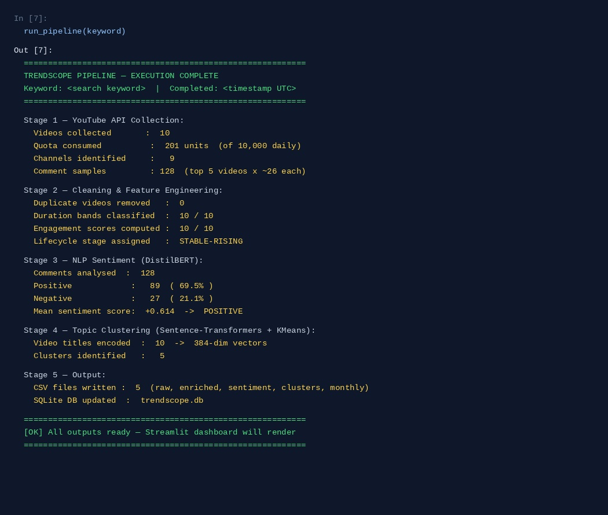
Output 7 — Full pipeline summary: 10 videos collected (201 quota units), all cleaned and scored, 128 comments classified by DistilBERT (69.5% positive), 5 topic clusters produced, 5 CSV files exported and SQLite database updated. Streamlit dashboard ready to render.

Appendix C: Power BI Data Model
The Power BI data model is built from five CSV files exported by the TrendScope pipeline. The relationships between tables in the Power BI model are:
From Table | From Column | To Table | To Column | Cardinality
videos | video_id | video_stats | video_id | One-to-One
videos | channel_id | channels | channel_id | Many-to-One
videos | video_id | comments | video_id | One-to-Many
videos | (keyword, year_month) | monthly_index | (keyword, year_month) | Many-to-One
videos | cluster_id | topics | cluster_id | Many-to-One

All relationships use single-direction filtering. The date table is a calculated DAX table generated from the min and max published_at values in the videos table, enabling standard Power BI time intelligence functions.

Key DAX Measures
The following DAX measures are used across the Power BI dashboard:
-- Engagement Score (Average)
Avg Engagement Score = AVERAGE(video_stats[engagement_score])

-- Sentiment Trend Score
Avg Sentiment = AVERAGE(comments[sentiment_score])

-- Month-over-Month Video Volume Change
MoM Video Change % =
DIVIDE(
[Video Count] - CALCULATE([Video Count], DATEADD(Dates[Date], -1, MONTH)),
CALCULATE([Video Count], DATEADD(Dates[Date], -1, MONTH))
)

-- Channel View Share
Channel View Share % =
DIVIDE(SUM(video_stats[views]), CALCULATE(SUM(video_stats[views]), ALL(channels)))

-- Trend Stage Label
Trend Stage = SELECTEDVALUE(monthly_index[trend_event], 'Stable')

References
Project GitHub Repository: https://github.com/aeshaalami-blip/GRAD-PROJECT-1
YouTube Data API v3 Documentation: https://developers.google.com/youtube/v3
Hugging Face Transformers Documentation: https://huggingface.co/docs/transformers
Sentence-Transformers Library: Reimers & Gurevych (2019). Sentence-BERT: Sentence Embeddings using Siamese BERT-Networks. EMNLP 2019.
Streamlit Documentation: https://docs.streamlit.io
Microsoft Power BI Documentation: https://docs.microsoft.com/en-us/power-bi
scikit-learn Documentation – K-Means Clustering: https://scikit-learn.org/stable/modules/clustering.html
spaCy Documentation: https://spacy.io/usage
PyVis Network Visualization: https://pyvis.readthedocs.io
pandas Documentation: https://pandas.pydata.org/docs
Google Cloud – YouTube API Quota Calculator: https://developers.google.com/youtube/v3/determine_quota_cost
DistilBERT Model Card: https://huggingface.co/distilbert-base-uncased-finetuned-sst-2-english
paraphrase-multilingual-MiniLM-L12-v2 Model Card: https://huggingface.co/sentence-transformers/paraphrase-multilingual-MiniLM-L12-v2

